

**C-DATA GPON OLT**

**User Manual**

**-- Installation and commissioning**

**FD1700S**



**Version: V1.0**

**Website: [www.cdatatec.com](http://www.cdatatec.com)**

**Copyright Reserved**

Without the prior written consent of C-DATA, any reproduction, excerpting, backup, modification, translation or any other form of commercial use of this document or any portion of this document, and in any form or by any means, to transmit the document are prohibited.

**Trademark Declaration**

**IMG_256**is a trademark or registered trademark of C-DATA and its affiliates. Without the prior written consent of C-DATA , no entity or individual may use, copy, modify, disseminate or bundle any part of the trademark, trade name or logo of C-DATA in any way or reason.

All other trademarks, product names, service names and company names mentioned in this document and mentioned in the products described in this document are the property of their respective holders.

**Disclaimer**

The information in this document is made based on the existing information and may be verified at any time due to product upgrade or any other reasons. We reserve the right to alter, modify or otherwise change in any manner the content hereof, without obligation of C-DATA to notify any person of such revision or changes. This document is for reference only.

C-DATA endeavors to ensure content accuracy and will not assume any responsibility for losses and damages caused due to content omissions, inaccuracies or errors. All statements, information, and recommendations in this document do not constitute a warranty of any kind, express or implied.

**Revision History**

|  |  |  |
| --- | --- | --- |
| Version | Release date | Update Notes |
| 1.0 | 2024/8/15 | First release |

Contents

[Contents 1](#_Toc4505)

[1 Hardware Installation 3](#_Toc13095)

[1.1 Installation method 3](#_Toc22215)

[1.1.1 Desktop installation 3](#_Toc22781)

[1.1.2 Cabinet installation 3](#_Toc14665)

[1.2 Preparation for Installation 4](#_Toc6410)

[1.3 Unpack inspection 5](#_Toc6026)

[1.4 Cable installation 5](#_Toc9136)

[1.4.1 Connect the power cord 6](#_Toc1404)

[1.4.2 Protected Place connection 6](#_Toc13770)

[1.4.3 Upper connector connection 7](#_Toc10875)

[1.4.4 PON port connection 8](#_Toc26506)

[1.4.5 Management Port connection 8](#_Toc6954)

[1.5 Power on and off the device 9](#_Toc19285)

[2 Initial configuration 11](#_Toc30560)

[2.1 Configuration preparation 11](#_Toc9353)

[2.2 Configuring base data 14](#_Toc5219)

[3 Basic Service Configuration 15](#_Toc32069)

[3.1 FTTH service networking 15](#_Toc32253)

[3.2 OLT profile type online service configuration -- command line mode 16](#_Toc23474)

[3.2.1 Data Planning 16](#_Toc11564)

[3.2.2 Configuration process 17](#_Toc6753)

[3.2.3 Global service vlan configuration on OLT 17](#_Toc2439)

[3.2.4 GE port service vlan configuration on OLT 17](#_Toc17587)

[3.2.5 ONT profile creation 18](#_Toc12937)

[3.2.6 DBA profile creation for ONT 18](#_Toc8039)

[3.2.7 Line profile creation for ONT 19](#_Toc14427)

[3.2.8 Service profile creation for ONT 19](#_Toc1735)

[3.2.9 Add the registered ONT manually 20](#_Toc26587)

[3.2.10 Check ONT registration status 20](#_Toc22281)

[3.2.11 Bridged (SFU) ONT online service configuration 21](#_Toc11248)

[3.2.12 Gateway (HGU) type ONT service configuration instructions 22](#_Toc30938)

[3.2.13 Create Auth Policy 22](#_Toc22124)

[3.2.14 Apply Policy 23](#_Toc15157)

[3.3 OLT profile-based Multicast service Configuration - Command line mode 23](#_Toc29962)

[3.3.1 Data Planning 23](#_Toc11502)

[3.3.2 Configuration process 24](#_Toc15177)

[3.3.3 Global service vlan configuration on OLT 24](#_Toc31641)

[3.3.4 GE port service vlan configuration on OLT 24](#_Toc4145)

[3.3.5 Multicast service configuration on OLT 25](#_Toc19133)

[3.3.6 ONT profile creation 25](#_Toc1872)

[3.3.7 DBA profile creation for ONT 26](#_Toc19815)

[3.3.8 Line profile creation for ONT 26](#_Toc1634)

[3.3.9 Service profile creation for ONT 27](#_Toc32159)

[3.3.10 Add the registered ONT manually 27](#_Toc9609)

[3.3.11 Check ONT registration status 28](#_Toc26709)

[3.3.12 Bridged (SFU) ONT online service configuration 29](#_Toc1540)

[3.3.13 Gateway (HGU) type ONT service configuration instructions 29](#_Toc31151)

[3.3.14 Create Auth Policy 30](#_Toc31674)

[3.3.15 Apply Policy 30](#_Toc21737)

[3.4 OLT online service configuration --WEB mode 30](#_Toc2077)

[3.4.1 Data planning 30](#_Toc23593)

[3.4.2 Log in to the OLT web management system 31](#_Toc22837)

[3.4.3 Creating a VLAN 32](#_Toc28659)

[3.4.4 Create ONT DBA Profile 33](#_Toc21958)

[3.4.5 Create ONT Lineprofile 34](#_Toc27415)

[3.4.6 Create ONT Srvprofile 36](#_Toc18421)

[3.4.7 Create ONT WAN Profile 38](#_Toc18267)

[3.4.8 Policy Application 40](#_Toc477)

[3.5 OLT multicast configuration -WEB mode 43](#_Toc30765)

[3.5.1 Data planning 43](#_Toc29673)

[3.5.2 Log in to the OLT web management system 43](#_Toc13340)

[3.5.3 Creating a VLAN 44](#_Toc11001)

[3.5.4 Create ONT DBA Profile 45](#_Toc27377)

[3.5.5 Create ONT Lineprofile 46](#_Toc7312)

[3.5.6 Create ONT Srvprofile 48](#_Toc21905)

[3.5.7 Create ONT WAN Profile 51](#_Toc6563)

[3.5.8 Policy Application 53](#_Toc13855)

[3.5.9 IGMP global configuration 56](#_Toc17606)

[3.5.10 Multicast forwarding 56](#_Toc20976)

[3.5.11 Multicast VLAN configuration 57](#_Toc3779)

[3.5.12 Multicast VLAN program added 57](#_Toc15435)

1. Hardware Installation

This chapter includes the following topics:

* Installation
* Preparation for installation
* Unpack and inspect the goods
* Cable installation
* Power on the device
  1. Installation method
     1. Desktop installation

Step I: Prepare for installation

* Ensure that the table is strong enough to support the weight of the equipment and the cable
* Ensure that there are no obstacles around the installation location of the workbench equipment

Step II: Lift the equipment and place it lightly on the front of the table

Step III: Move the device to the designated location

* + 1. Cabinet installation

The OLT can be installed in a 19-inch ETSI standard rack as shown below:

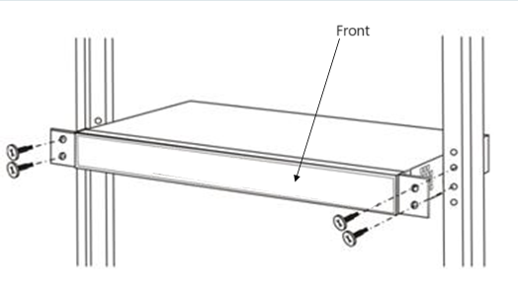

FIG.1 Schematic diagram of the cabinet installation

The installation process is as follows:

Step I: Confirm before installation

* Make sure the rack is installed and there are no obstacles in the installation location of the equipment.
* Prepare the equipment and move the equipment to a convenient location for installation.

Step II: Move the equipment from the front of the rack to the mounting position above the rack tray.

Step III: Bolt the device to the 19-inch rack.

* 1. Preparation for Installation

Check the following work environment requirements:

1. Power supply requirements:

-DC, voltage fluctuation allowable range :-40V ~ -72V

-AC power supply: 100V ~ 240V，47~63Hz

2. Equipment should be installed in a dry and cool place, at least 10 cm away from the surrounding for ventilation.

3. Avoid direct light and stay away from heat sources and other strong electromagnetic interference sources.

4. When OLT is installed in the frame, it should be equipped with the corresponding bolts, nuts and tools.

5. Check the cables and connectors used for installation.

6. For management, the following equipment should be configured to connect the OLT:

-Management platform, such as PC

- RJ45/DB9 RS232 Console line

* 1. Unpack inspection

According to the packing list or contract, and check the products. If there is any omission, error or damage, please contact your customer service manager in time.

The list includes the following components:

* One OLT host
* SFP module configured according to customer order
* AC power cord or DC power accessories
  1. Cable installation

The cables of FD1700S include ground, power, configuration, network and fiber.

**Installation Specifications**

* Layout principles

The power cable should be straight and smooth in arc.

The power cable should use the whole section of wire material, there should be no joint or solder joint in the middle.

The excess part of the power cable should be cut off and not coiled.

The bending radius of the power cable when turning should be greater than 5 times the diameter of the cable.

After the power cable is laid out, there should be no crossing, no winding, no distortion, and moderate tightness.

The signal cable must be tested before installation, and both ends should be marked or glued to the engineering label.

When laying the power cable and the signal cable, it is necessary to ensure that the distance is at least 300mm. It is strictly forbidden to tie the two together.

Optical fiber should consider the turning radius. Generally, the turning radius of optical fiber cannot be less than 4cm.

* Principles of binding

When the power cable is tied, it should be tied separately from the signal line.

The binding distance of each section of the power cable is 200mm.

Cable installation and placement should avoid the door and other rotating parts to squeeze and pull the cable, and should not be tied at the turn.

The cable buckle should be in the same direction, and the excess part should be cut off after tying, and the cutting edge should be flat and not pointed.

* The upper line principle

The cable is led from the top of the DC distribution cabinet to the wire rack, and is placed on the top of the equipment cabinet along the wire rack.

* The principle of wiring down

The cable leads from the bottom of the DC distribution cabinet, and runs under the anti-static floor to the underside of the equipment cabinet.

* + 1. Connect the power cord

**Connect the AC power supply**

The device supports dual power supply 1 + 1 redundant backup. If one of the power supplies fails, the system can continue to work with the remaining power supply modules. To ensure power input redundancy, it is recommended to connect the two power supplies to separate power lines. UPS power supply can also be used to provide reliability of power supply.

1. Find the AC power cord in the accessories of the OLT.

2. Connect one end of the power cord to the power connection inlet in the back panel of the OLT.

3. Connect the other end to the AC power supply socket.

* + 1. Protected Place connection

In order to ensure the normal and stable operation of OLT, the equipment should be grounded. The grounding screw is located on the left side of the rear panel of the equipment. To connect, loosen the grounding screw first, connect the grounding cable, and lock the screw. The appearance of the protective grounding wire of the equipment is shown in the figure:



FIG.2 Schematic diagram of equipment protection ground

Connect one end of the yellow and green double-color protective grounding cable of OLT to the terminal post of the grounding row, and tighten the fixing nut, as shown in the figure:

The protective grounding wire of the equipment is connected

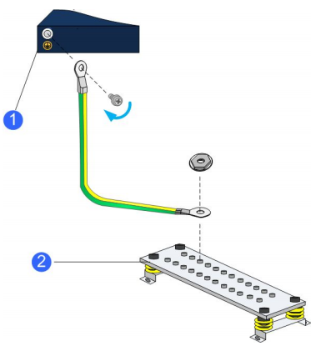

1.OLT protective ground connection terminal
2. Ground row in computer room

FIG.3 Protective ground connection

* + 1. Upper connector connection

**Port Description**

The OLT provides 4\*1G(SFP)/10G SFP+, 4\*10G(SFP+)/25G(SFP28) uplink ports that can be connected to the OLT and uplink devices using fiber.

The maximum transmission range is up to 10-40Km when using single-mode fiber and less than 500m when using multi-mode fiber.

**Port connections**

There are one way to connect the uplink:

* Fiber optic with LC connector

The upper link uses the optical port, use the fiber optic jumper with the LC connector to connect.

* + 1. PON port connection

FD1700S has two card slots,support GPON SFP and XGSPON SFP,GPON's optical module supports Class B+, Class C++, Class C+++, and ClassC++++ ,XGSPON’s optical module support Class B+, Class C+, and Class D .These two card slots can be selected from these four types,they are FD7041T(4\*GPON);FD7081T(8\*GPON); FD7161T(16\*GPON);FD8081T(8\*XG(S)PON).

FD1700S fully complies with the relevant standards of ITU G.984.x and ITU G.9807.x.

* + 1. Management Port connection

The OLT provides console management interface (marked as "CONSOLE", RJ45 interface) and MGMT management interface (marked as "MGMT", RJ45 interface) to configure the device locally.

To access the device from the Console port, the following tools are required:

* Console cable: RJ-45 turn DB-9 console cable
* Terminal software: Super Terminal

The Console cable is used to connect the serial port of the PC and the Console port of the device. Most computers or laptops no longer have a built-in serial port.

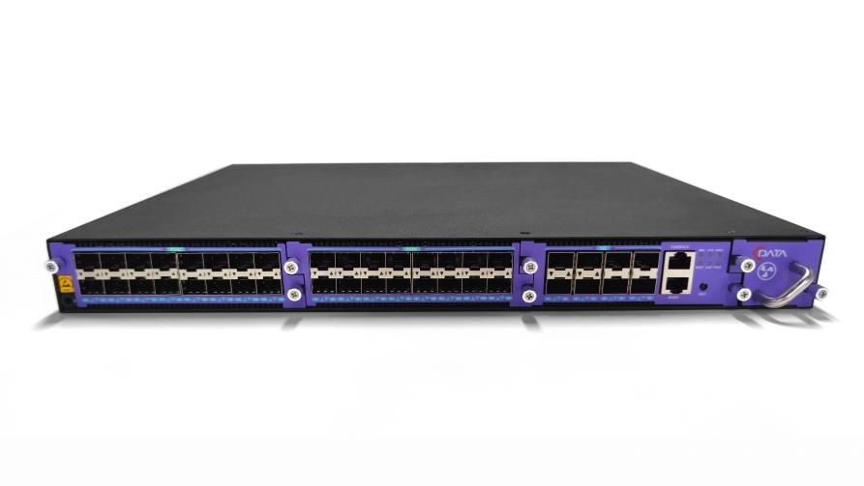

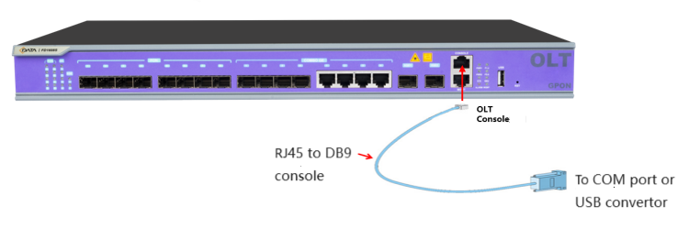

Figure.4 Schematic of managing serial port connections

Table 3 Manage serial cable demand Table

|  |  |  |
| --- | --- | --- |
| Computer ports | Cable | OLT interface |
| Serial port | RJ-45 RPM DB-9 Console cable | RJ-45 Console port |

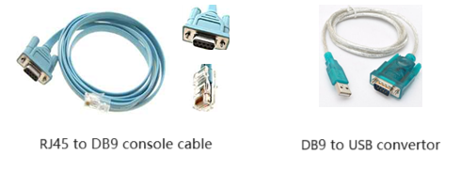

Figure.5 Schematic diagram of the management serial port cable

* 1. Power on and off the device

Before the FD1700S is powered on, it is necessary to check the environment of the computer room and the hardware installation.

1. In order to ensure the normal operation and service life of the equipment, a certain temperature and humidity should be maintained in the computer room.

* If the long-term humidity in the computer room is too high, it is easy to cause poor insulation or even leakage of insulation materials, and sometimes it is also easy to change the mechanical properties of materials and rust of metal parts. If the relative humidity is too low, the insulation gasket will dry and shrink and cause the tightening screw to loosen. At the same time, in a dry climate environment, it is easy to generate static electricity and harm the circuit on the equipment.
* High temperature is more harmful, long-term high temperature will accelerate the aging process of insulation materials, greatly reducing the reliability of the equipment, seriously affecting its life.

2. Check whether the power cord and cable are correct and reliable.

3. Check other hardware.

* Equipment labels are complete, correct, and clear.
* Whether the device is securely mounted to the 19-inch standard rack and smoothly mounted to the desktop.
* Whether the rack is well grounded and whether the grounding resistance meets the technical requirements.

4. The steps for powering up FD1700S are as follows:

a. Plug in the AC/DC power cable of the device.

b. Turn on an external power source.

5. Check the OLT working status.

* Check the power LED. The power LED should be green and always on.
* The SYS LED indicator flashes every 1 second.
* The indicator light connected to the uplink port of the uplink device lights up.

6. The steps to power down the FD1700S are as follows:

a. Turn off the external power supply.

b. Unplug the AC/DC power cord of the device.

1. Initial configuration

This chapter includes the following topics:

* Configuration Preparation
* Configure base data
  1. Configuration preparation

**Hardware requirements**

* The hardware is already installed.
* The wires are connected properly.
* The power supply is in place and the device has been powered on.

**Software Requirements**

* Network management software has been installed.
* The device version meets the business requirements.

The out-of-band network management IP address of FD17 series is 192.168.100.1. After logging into the network element through the serial port, the out-of-band network management IP address can be viewed using OLT(config)# show interface mgmt command.

**Configure the serial port test and maintenance terminal**

* Use the serial port cable to connect the CONSOLE port of the device and the serial port of the debugging terminal (PC).
* In the debug console, run the terminal tool (PuTTY for example).
* In the PuTTY dialog box, select Serial as Connection type, select COM port according to the connection of serial port cable (COM1 in this case), and click the "Open" button when the configuration is complete. Set COM port properties as shown in the following picture:

**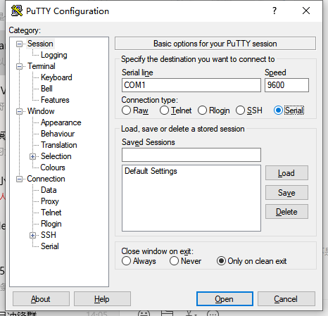**

Figure.6 Set COM attribute (Baud rate of OLT of C-DATA Company is 115200 or 9600)

When the serial port tool successfully connects to the OLT, in the displayed command line, username input: root password input: admin



FIG.7 Schematic diagram of OLT console connection

Table 4 Devices required for OLT console connection

|  |  |  |
| --- | --- | --- |
| PC interface | Cables required for PC and OLT connection | OLT interface |
| Serial port | RJ-45 RPM DB-9 Console cable | Console port |

**Configure out-of-band network port test and maintenance terminal**

* Use the network cable to connect the MGMT network port of the device and the network port of the debug terminal (PC).
* On the debug terminal, run the terminal tool (take PuTTY as an example).
* After running Putty, select the Telnet button for Connection type, and the IP entered under Host Name (or IPaddress) is the out-of-band management IP of OLT. Here, 192.168.100.1 is taken as an example. After the configuration is completed, click the "Open" button. Set the Telnet property as shown in the following figure:

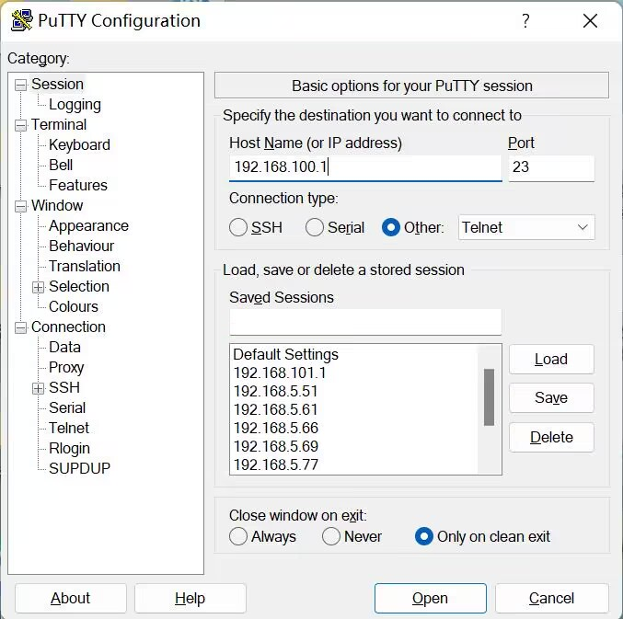

Figure.8 Set the Telnet property

**Login device**

You must login to OLT before configuring OLT. Whether it is serial port login or out-of-band management port login, the following interface will pop up. Enter the user name and password (the administrator's account and password are root/admin) and then enter the administrator mode. For other configuration commands, please refer to "C-Data FD1700S User Manual - Command Reference".

*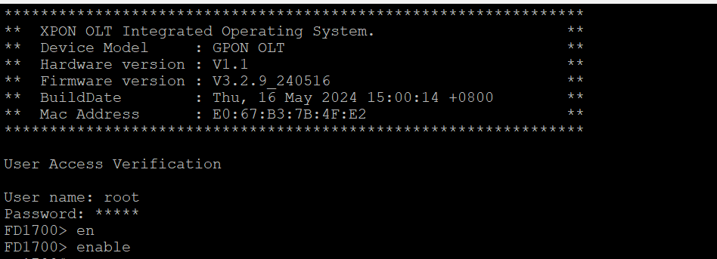*

Fig.9 Login the device

* 1. Configuring base data

**The first: out-of-band management (connect OLT MGMT port)**

The IP address of 192.168.100.X (except 192.168.100.1) network segment is added to the PC, the network port of PC is connected to the MGMT port of OLT, and the default management IP of OLT is used for telnet login. The default management ip of OLT is 192.168.100.1. After logging in, input the user name and password as root/admin

The out-of-band management IP on OLT is set as follows:

|  |
| --- |
| OLT> enable  OLT# config  OLT(config)# interface mgmt  OLT(config-interface-mgmt)# ip address 192.168.5.100 24  OLT(config-interface-mgmt)# exit |

**The second: in-band management (connected to the GE port of the OLT)**

First log in OLT with Console port or out-of-band management mode, then establish a vlan layer 3 interface in OLT, configure an ip to the vlan interface, and add the corresponding uplink port to the vlan (the uplink vlan mode can be access or trunk mode, according to their own network specifications to configure). The PC connects to the OLT uplink port (ge1-ge4) for telnet login.

The OLT in-band management IP Settings are as follows:

|  |
| --- |
| OLT> enable  OLT# config  OLT(config)# vlan 100  OLT(config)# interface eth 0/0  OLT(interface-eth-0/0)# vlan access 1 100 / Here is to configure GE1 as an in-band management port  OLT(interface-eth-0/0)# exit  OLT(config)# interface vlanif 100  OLT(interface-vlanif-100)# ip address 192.168.100.1 255.255.255.0  OLT(interface-vlanif-100)# exit |

1. Basic Service Configuration

This chapter includes the following topics:

* FTTH service networking
* OLT profile-based online service configuration - Command line mode
* OLT profile-based multicast service configuration - Command line mode
* OLT Online service configuration -WEB mode
* OLT multicast service configuration -WEB mode
  1. FTTH service networking

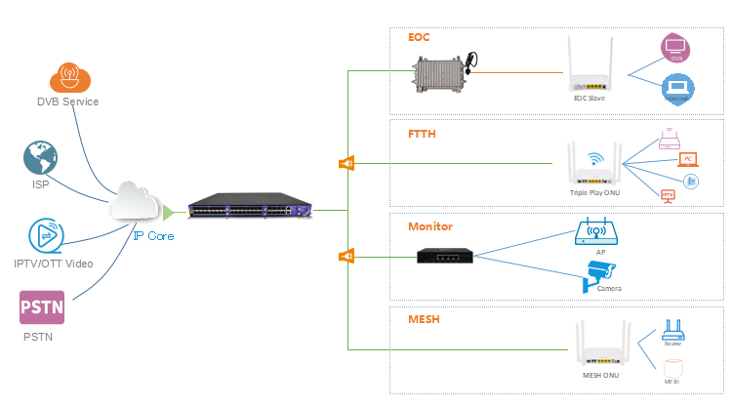

FIG.10 FTTH service networking diagram

* 1. OLT profile type online service configuration -- command line mode

This section is mainly used to introduce the OLT in the profile mode of FTTH networking scene online service configuration. The configuration of profile type can configure different business profiles according to different types of ONT, which can be handled flexibly. This paper mainly introduces the SFU type and HGU type ONT respectively. The following will introduce the service configuration methods of the two forms of ONT.

* + 1. Data Planning

Table 9 Data Planning Table

|  |  |
| --- | --- |
| List of key data planning | |
| Configuration items | Specific data |
| OLT Port Configuration | GE1: VLAN 100 access mode |
| DBA profile (Uplink bandwidth control) | Profile No. : 4 |
| ONT Line profile | Profile Number: 4  T-CONT ID used: 1  Online service GEM Port ID: 1 Mapping Vlan: 100 |
| ONT Service profile | Profile Number: 4  ONT Port Capability Set: Adaptive |
| Bridged ONT port configuration | LAN1: VLAN 100 |
| Gateway type ONT port configuration | LAN1: VLAN 100 |

* + 1. Configuration process

Create global VLAN

Create uplink VLAN

Start

Create WAN（HGU ONU）

Save configuration

Create DBA profile

Create line profile

Create service profile

End

Apply policy

Create auth policy

FIG.11 Configuration process of OLT profile type online service

* + 1. Global service vlan configuration on OLT

The command OLT(config)# show vlan all in config mode on the OLT can be used to query the created vlan.

If the created vlan cannot meet the requirements, the OLT(config)# vlan vLAN-list command can be used to create the vlan. According to the data planning, we first create the vlan100:

|  |
| --- |
| OLT(config)# vlan 100 |

* + 1. GE port service vlan configuration on OLT

The vlan mode of GE port on the upper link is divided into access, hybrid and trunk, which can be configured according to their own network planning. Each configuration method is as follows:

**Configure GE 1 port vlan mode for access (start guide GE port with access mode) :**

|  |
| --- |
| OLT(config)# interface eth 0/0  OLT(config-eth-0/0)# vlan mode 1 access  OLT(config-eth-0/0)# vlan access 1 100  OLT(config-eth-0/0)# exit |

**Configure GE 1-port vlan mode to trunk:**

|  |
| --- |
| OLT(config)# interface eth 0/0  OLT(config-eth-0/0)# vlan mode 1 trunk  OLT(config-eth-0/0)# vlan trunk 1 100  OLT(config-eth-0/0)# exit |

**Configure GE 1-port vlan mode to hybrid:**

|  |
| --- |
| OLT(config)# interface eth 0/0  OLT(config-eth-0/0)# vlan mode 1 hybrid  OLT(config-eth-0/0)# vlan hybrid 1 tagged 100  OLT(config-eth-0/0)# exit |

* + 1. ONT profile creation

GPON ONT profiles include DBA profiles, line profiles, and service profiles.

* DBA profile: DBA profile describes the traffic parameters of GPON, T-CONT dynamically allocates bandwidth by binding DBA profile to improve uplink bandwidth utilization.
* Line profile: The line profile describes the binding relationship between T-CONT and DBA profile, the QoS pattern of the traffic flow, the mapping relationship between GEM Port and ONT side traffic, etc.
* Service profile: The service profile provides a service configuration channel for ONT managed by OMCI.
  + 1. DBA profile creation for ONT

You can query existing DBA profiles in your system using the show dBA-profile all command. If the existing dba profiles in the system do not meet the requirements, you will need to execute dba-profile to add them. Create different DBA profiles for different business types.

**Create DBA profile number 1, type Type3, guaranteed bandwidth of 8Mbit/s, maximum bandwidth of 20Mbit/s:**

|  |
| --- |
| OLT(config)# dba-profile profile-id 4  OLT(config-dba-profile-1)# type3 assure 8192 max 20480  OLT(config-dba-profile-1)# commit  OLT(config-dba-profile-1)# exit |

Note:

DBA is scheduled based on the whole ONT, and the appropriate bandwidth type and bandwidth size should be selected according to the service type and the number of users in ONT. Please note that the sum of fixed bandwidth (fix) and guaranteed bandwidth (assure) cannot be greater than the total bandwidth of the PON interface.

* + 1. Line profile creation for ONT

**Create the GPON ONT line profile with profile number 4 and bind the DBA profile 1**

|  |
| --- |
| OLT(config)# ont-lineprofile gpon profile-id 4  OLT(config-ont-lineprofile-4)# tcont 1 dba-profile-id 4 |

**Create different GEM ports for different service types. GEM ports with index 1 are used to host online services.**

|  |
| --- |
| OLT(config-ont-lineprofile-4)# gem add 1 tcont 1 |

**Configure the mapping mode of GEM PORT to vlan.**

|  |
| --- |
| OLT(config-ont-lineprofile-4)# mapping-mode vlan |

**Different GEM ports are mapped to different VLans for different service types. Among them, the GEM Port with index 1 is mapped to VLAN100 for carrying online services.**

|  |
| --- |
| OLT(config-ont-lineprofile-4)# gem mapping 1 1 vlan 100 |

**Once the configuration is complete, use the commit command to make the configured parameters take effect**

|  |
| --- |
| OLT(config-ont-lineprofile-4)# commit  OLT(config-ont-lineprofile-4)# exit |

* + 1. Service profile creation for ONT

**Create the GPON ONT Service profile with profile number 4. Configure the number of ETH ports and the number of POTS ports for ONT to be adaptive:**

|  |
| --- |
| OLT(config)# ont-srvprofile gpon profile-id 4  OLT(config-ont-srvprofile-4)# ont-port eth adaptive  OLT(config-ont-srvprofile-4)# ont-port pots adaptive  OLT(config-ont-srvprofile-4)# ont-port catv adaptive  OLT(config-ont-srvprofile-4)# ont-port iphost adaptive  OLT(config-ont-srvprofile-4)# commit  OLT(config-ont-srvprofile-4)# exit |

**Once the configuration is complete, use the commit command to make the configured parameters take effect**

|  |
| --- |
| OLT(config-ont-srvprofile-4)# commit  OLT(config-ont-srvprofile-4)# exit |

* + 1. Add the registered ONT manually

**1. Change the ONT authentication method for PON ports to manual registration:**

|  |
| --- |
| OLT(config)# interface gpon 0/1  OLT(config-interface-gpon-0/1)# ont authmode all manual |

**2. Open the ONT auto-discovery function of PON port:**

|  |
| --- |
| OLT(config)# interface gpon 0/1  OLT(config-interface-gpon-0/1)#ont autofind 1 enable  OLT(config-interface-gpon-0/1)#show ont autofind 0/1 1 all  // This command displays information about all unregistered ONTs that are connected to this GPON port through the splitter |

* + 1. Check ONT registration status

After adding ONT, use the show ont info command to query ONT's on-line status, Make sure the ONT's "Control flag" is "Active," "Run State" is "Online," "Config state" is "Success," and "Match state" is "Match."

|  |
| --- |
| OLT(config-interface-gpon-0/1)# show ont info 1 all  -------------------------------------------------------------------------------------------------------  F/S P ONT MAC Control Run Config Match  ID flag state state state  0/1 1 1 DB19B34F0C16 active online success match  0/1 1 2 XPONE067B341 active online success match  Total: 2, online 2, deactive: 0, failed: 0 |

When the ONT configuration state fails, ONT fails to up, etc. :

* If the "Control flag" is "deactive", the ont needs to be activated using the ont activate command in GPON port mode.
* If the ONT fails to go online, that is, the "Run state" is "offline", it may be the physical line interruption, or the optical module damage, and it needs to be checked from both aspects of the device and the line.
* If the ONT configuration state fails, that is, the "Config state" is "failed", it means that the configured ONT is not applicable to some configurations in the service profile, and it is necessary to capture packets on the ONT to analyze which configurations are not accepted by the ONT.
* If the "Match state" of ONT is "Mismatch", it means that the ONT capability set configured by the service profile (number of ports) and the actual capability set of ONT do not match. You can use the show ont capability with the show ont config-capability command to compare the ONT actual capability set with the set of capabilities configured in the business profile.
  + 1. Bridged (SFU) ONT online service configuration

ONT Online service opening preconditions:

* OLT has connected the uplink equipment and opened the Internet service
* The OLT has created an Internet vlan
* The OLT has been configured with an Internet vlan with GE port
* The ONT has registered and bound the line profile and service profile

The port vlan mode of the bridged ONT is divided into pass-through, tag (access) and trunk modes. By default, ONT focuses on port native vlan. If ONT wants to work in pass-through mode, it needs to be configured to not focus on port native vlan in the service profile. The profile configuration is described as follows.

**Configure the ONT port vlan mode in the service profile to tag (access) :**

|  |
| --- |
| OLT(config)# ont-srvprofile gpon profile-id 4  OLT(config-ont-srvprofile-4)# port vlan eth 1 100  OLT(config-ont-srvprofile-4)# port native-vlan eth 1 100  OLT(config-ont-srvprofile-4)# commit  OLT(config-ont-srvprofile-4)# exit |

**Configure virtual port auto-configuration in line profile:**

Service VLAN is 100, ONT ID is 1, GEM Port ID is 1, user side VLAN is 100.

|  |
| --- |
| OLT(config-ont-lineprofile-4)#gemport 1 vlan 100 user-vlan 100 tag-action transparent  Config a bridge WAN in onu web |

* + 1. Gateway (HGU) type ONT service configuration instructions

**Prerequisites**

* The OLT has connected the uplink device and opened the Internet service
* The OLT has created an Internet vlan
* The OLT has been configured with an Internet vlan with GE port
* ONT registered

**Configure automatic configuration of virtual port in line profile:**

Service VLAN is 100, ONT ID is 1, GEM Port ID is 1, user side VLAN is 100.

|  |
| --- |
| OLT(config-ont-lineprofile-4)#gemport 1 vlan 100 user-vlan 100 tag-action transparent |

**Create a route WAN(this ONU is C-Data ONU):**

|  |
| --- |
| OLT(config-gpon-0/1)# ont wan 1 1 1 vlan 100 ipv4 dhcp  OLT(config-gpon-0/1)#ont wan 1 1 1 option mtu 1500 service-type internet |

* + 1. Create Auth Policy

|  |
| --- |
| OLT(config)#ont mult-srv-profile gpon profile-id 4  OLT(config-mult-srv-profile-4)#ont-line-profile profile-id 4  OLT(config-mult-srv-profile-4)#ont-srv-profile profile-id 4 |

* + 1. Apply Policy

|  |
| --- |
| OLT(config-gpon-0/1)# ont policy-auth 4 match any sn-auth to mult-srv-profile profile-id 4 priority 1 |

* 1. OLT profile-based Multicast service Configuration - Command line mode

This section is mainly used to introduce the configuration of multicast service in FTTH networking scenario of new 8-port OLT and new 16-port OLT in profile mode. The configuration of profile mode can configure different service profiles according to different types of ONT, which can be handled flexibly. This paper mainly introduces the SFU type and HGU type ONT respectively. The following will introduce the service configuration methods of the two forms of ONT.

* + 1. Data Planning

Table 9 Data Planning Table

|  |  |
| --- | --- |
| List of key data planning | |
| Configuration items | Specific data |
| OLT Port Configuration | GE1: VLAN 100 access mode |
| DBA profile (Uplink bandwidth control) | Profile No. : 4 |
| ONT Line profile | Profile Number: 4  T-CONT ID used: 1  Online service GEM Port ID: 1 Mapping Vlan: 100 |
| ONT Service profile | Profile Number: 4  ONT Port Capability Set: Adaptive |
| Bridged ONT port configuration | LAN1: VLAN 100 |
| Gateway type ONT port configuration | LAN1: VLAN 100 |

* + 1. Configuration process

Multicast service config

Create global VLAN

Create uplink VLAN

Start

Create WAN（HGU ONU）

Save configuration

Create DBA profile

Create line profile

Create service profile

End

Apply policy

Create auth policy

FIG.12 Configuration process of OLT profile type online service

* + 1. Global service vlan configuration on OLT

The command OLT(config)# show vlan all in config mode on the OLT can be used to query the created vlan.

If the created vlan cannot meet the requirements, the OLT(config)# vlan vLAN-list command can be used to create the vlan. According to the data planning, we first create the vlan100:

|  |
| --- |
| OLT(config)# vlan 100 |

* + 1. GE port service vlan configuration on OLT

The vlan mode of GE port on the upper link is divided into access, hybrid and trunk, which can be configured according to their own network planning. Each configuration method is as follows:

**Configure GE 1 port vlan mode for access (start guide GE port with access mode) :**

|  |
| --- |
| OLT(config)# interface eth 0/0  OLT(config-eth-0/0)# vlan mode 1 access  OLT(config-eth-0/0)# vlan access 1 100  OLT(config-eth-0/0)# exit |

**Configure GE 1-port vlan mode to trunk:**

|  |
| --- |
| OLT(config)# interface eth 0/0  OLT(config-eth-0/0)# vlan mode 1 trunk  OLT(config-eth-0/0)# vlan trunk 1 100  OLT(config-eth-0/0)# exit |

**Configure GE 1-port vlan mode to hybrid:**

|  |
| --- |
| OLT(config)# interface eth 0/0  OLT(config-eth-0/0)# vlan mode 1 hybrid  OLT(config-eth-0/0)# vlan hybrid 1 tagged 100  OLT(config-eth-0/0)# exit |

* + 1. Multicast service configuration on OLT

Configure multicast mode and multicast vlan 100

|  |
| --- |
| OLT(config)# igmp mode snooping  OLT(config)# multicast-vlan 100  OLT(config-multicast-vlan-100)# igmp router-port eth 0/0/3  OLT(config-multicast-vlan-100)# igmp program add Program-index 1 ip 224.3.3.3  OLT(config-multicast-vlan-100)# exit |

* + 1. ONT profile creation

GPON ONT profiles include DBA profiles, line profiles, and service profiles.

* DBA profile: DBA profile describes the traffic parameters of GPON, T-CONT dynamically allocates bandwidth by binding DBA profile to improve uplink bandwidth utilization.
* Line profile: The line profile describes the binding relationship between T-CONT and DBA profile, the QoS pattern of the traffic flow, the mapping relationship between GEM Port and ONT side traffic, etc.
* Service profile: The service profile provides a service configuration channel for ONT managed by OMCI.
  + 1. DBA profile creation for ONT

You can query existing DBA profiles in your system using the show dBA-profile all command. If the existing dba profiles in the system do not meet the requirements, you will need to execute dba-profile to add them. Create different DBA profiles for different business types.

**Create DBA profile number 1, type Type3, guaranteed bandwidth of 8Mbit/s, maximum bandwidth of 20Mbit/s:**

|  |
| --- |
| OLT(config)# dba-profile profile-id 4  OLT(config-dba-profile-1)# type3 assure 8192 max 20480  OLT(config-dba-profile-1)# commit  OLT(config-dba-profile-1)# exit |

Note:

DBA is scheduled based on the whole ONT, and the appropriate bandwidth type and bandwidth size should be selected according to the service type and the number of users in ONT. Please note that the sum of fixed bandwidth (fix) and guaranteed bandwidth (assure) cannot be greater than the total bandwidth of the PON interface.

* + 1. Line profile creation for ONT

**Create the GPON ONT line profile with profile number 4 and bind the DBA profile 1**

|  |
| --- |
| OLT(config)# ont-lineprofile gpon profile-id 4  OLT(config-ont-lineprofile-4)# tcont 1 dba-profile-id 4 |

**Create different GEM ports for different service types. GEM ports with index 1 are used to host online services.**

|  |
| --- |
| OLT(config-ont-lineprofile-4)# gem add 1 tcont 1 |

**Configure the mapping mode of GEM PORT to vlan.**

|  |
| --- |
| OLT(config-ont-lineprofile-4)# mapping-mode vlan |

**Different GEM ports are mapped to different VLans for different service types. Among them, the GEM Port with index 1 is mapped to VLAN100 for carrying online services.**

|  |
| --- |
| OLT(config-ont-lineprofile-4)# gem mapping 1 1 vlan 100 |

**Once the configuration is complete, use the commit command to make the configured parameters take effect**

|  |
| --- |
| OLT(config-ont-lineprofile-4)# commit  OLT(config-ont-lineprofile-4)# exit |

* + 1. Service profile creation for ONT

**Create the GPON ONT Service profile with profile number 4. Configure the number of ETH ports and the number of POTS ports for ONT to be adaptive:**

|  |
| --- |
| OLT(config)# ont-srvprofile gpon profile-id 4  OLT(config-ont-srvprofile-4)# ont-port eth adaptive  OLT(config-ont-srvprofile-4)# ont-port pots adaptive  OLT(config-ont-srvprofile-4)# ont-port catv adaptive  OLT(config-ont-srvprofile-4)# ont-port iphost adaptive  OLT(config-ont-srvprofile-4)# commit  OLT(config-ont-srvprofile-4)# exit |

**Once the configuration is complete, use the commit command to make the configured parameters take effect**

|  |
| --- |
| OLT(config-ont-srvprofile-4)# commit  OLT(config-ont-srvprofile-4)# exit |

* + 1. Add the registered ONT manually

**1. Change the ONT authentication method for PON ports to manual registration:**

|  |
| --- |
| OLT(config)# interface gpon 0/1  OLT(config-interface-gpon-0/1)# ont authmode all manual |

**2. Open the ONT auto-discovery function of PON port:**

|  |
| --- |
| OLT(config)# interface gpon 0/1  OLT(config-interface-gpon-0/1)#ont autofind 1 enable  OLT(config-interface-gpon-0/1)#show ont autofind 0/1 1 all  // This command displays information about all unregistered ONTs that are connected to this GPON port through the splitter |

* + 1. Check ONT registration status

After adding ONT, use the show ont info command to query ONT's on-line status, Make sure the ONT's "Control flag" is "Active," "Run State" is "Online," "Config state" is "Success," and "Match state" is "Match."

|  |
| --- |
| OLT(config-interface-gpon-0/1)# show ont info 1 all  -------------------------------------------------------------------------------------------------------  F/S P ONT MAC Control Run Config Match  ID flag state state state  0/1 1 1 DB19B34F0C16 active online success match  0/1 1 2 XPONE067B341 active online success match  Total: 2, online 2, deactive: 0, failed: 0 |

When the ONT configuration state fails, ONT fails to up, etc. :

* If the "Control flag" is "deactive", the ont needs to be activated using the ont activate command in GPON port mode.
* If the ONT fails to go online, that is, the "Run state" is "offline", it may be the physical line interruption, or the optical module damage, and it needs to be checked from both aspects of the device and the line.
* If the ONT configuration state fails, that is, the "Config state" is "failed", it means that the configured ONT is not applicable to some configurations in the service profile, and it is necessary to capture packets on the ONT to analyze which configurations are not accepted by the ONT.
* If the "Match state" of ONT is "Mismatch", it means that the ONT capability set configured by the service profile (number of ports) and the actual capability set of ONT do not match. You can use the show ont capability with the show ont config-capability command to compare the ONT actual capability set with the set of capabilities configured in the business profile.
  + 1. Bridged (SFU) ONT online service configuration

ONT Online service opening preconditions:

* OLT has connected the uplink equipment and opened the Internet service
* The OLT has created an Internet vlan
* The OLT has been configured with an Internet vlan with GE port
* The ONT has registered and bound the line profile and service profile

The port vlan mode of the bridged ONT is divided into pass-through, tag (access) and trunk modes. By default, ONT focuses on port native vlan. If ONT wants to work in pass-through mode, it needs to be configured to not focus on port native vlan in the service profile. The profile configuration is described as follows.

**Configure the ONT port vlan mode in the service profile to tag (access) :**

|  |
| --- |
| OLT(config)# ont-srvprofile gpon profile-id 4  OLT(config-ont-srvprofile-4)# port vlan eth 1 100  OLT(config-ont-srvprofile-4)# port native-vlan eth 1 100  OLT(config-ont-srvprofile-4)# commit  OLT(config-ont-srvprofile-4)# exit |

**Configure virtual port auto-configuration in line profile:**

Service VLAN is 100, ONT ID is 1, GEM Port ID is 1, user side VLAN is 100.

|  |
| --- |
| OLT(config-ont-lineprofile-4)#gemport 1 vlan 100 user-vlan 100 tag-action transparent |

* + 1. Gateway (HGU) type ONT service configuration instructions

**Prerequisites**

* The OLT has connected the uplink device and opened the Internet service
* The OLT has created an Internet vlan
* The OLT has been configured with an Internet vlan with GE port
* ONT registered

**Configure automatic configuration of virtual port in line profile:**

Service VLAN is 100, ONT ID is 1, GEM Port ID is 1, user side VLAN is 100.

|  |
| --- |
| OLT(config-ont-lineprofile-4)#gemport 1 vlan 100 user-vlan 100 tag-action transparent |

**Then create a bridge WAN(this ONU is C-Data ONU):**

|  |
| --- |
| OLT(config-gpon-0/1)# ont wan 1 1 1 vlan 100 bridge |

* + 1. Create Auth Policy

|  |
| --- |
| OLT(config)#ont mult-srv-profile gpon profile-id 4  OLT(config-mult-srv-profile-4)#ont-line-profile profile-id 4  OLT(config-mult-srv-profile-4)#ont-srv-profile profile-id 4 |

* + 1. Apply Policy

|  |
| --- |
| OLT(config-gpon-0/1)# ont policy-auth 4 match any sn-auth to mult-srv-profile profile-id 4 priority 1 |

* 1. OLT online service configuration --WEB mode
     1. Data planning

|  |  |
| --- | --- |
| List of key data planning | |
| Configuration items | Specific data |
| OLT Port configuration | GE1: VLAN 3001 access mode |
| DBA profile (Uplink Bandwidth control) | Profile No. : 4 |
| Lineprofile | Profile No. : 4  TCONT ID : 1  GEM Port ID:1 |
| Srvprofile | Profile No. : 4  ONT port Capability set:Adaptive |
| Bridge-type ONT port configuration | LAN1: VLAN 3001 |
| Gateway type ONT port configuration | LAN1: VLAN 3001 |

* + 1. Log in to the OLT web management system

**Prerequisites**

The OLT Web management system adopts B/S architecture, please ensure that the network connection between the current PC and OLT equipment is normal and the OLT equipment is working properly before logging in.

**Background Information**

OLT Web provides four initial users by default, as follows:

Table 14 OLT Web Initial user Table

|  |  |  |  |
| --- | --- | --- | --- |
| User name | Roles | Password | Notes |
| root | Root | admin | This user has all the operation rights of all the objects managed by the OLT Web management system |
| admin | Admin | admin | This user has all the operation rights of OLT Web management system except for user deletion |
| operator | Operator | admin | The user has access and operation rights to common functions of OLT Web management system |
| guest | Guest | guest | This user has access only |

**Log in to the OLT Web management system**

* Enter the out-of-band management IP address (192.168.100.1 by default) or in-band management IP of the OLT device in the browser address bar to access the login page of the OLT Web management system.
* Enter the username and password on the login page and click the "Login" button;
* After the user successfully logs in, the system will jump to the main page of the OLT Web management system, and the typical initial page is shown in the figure

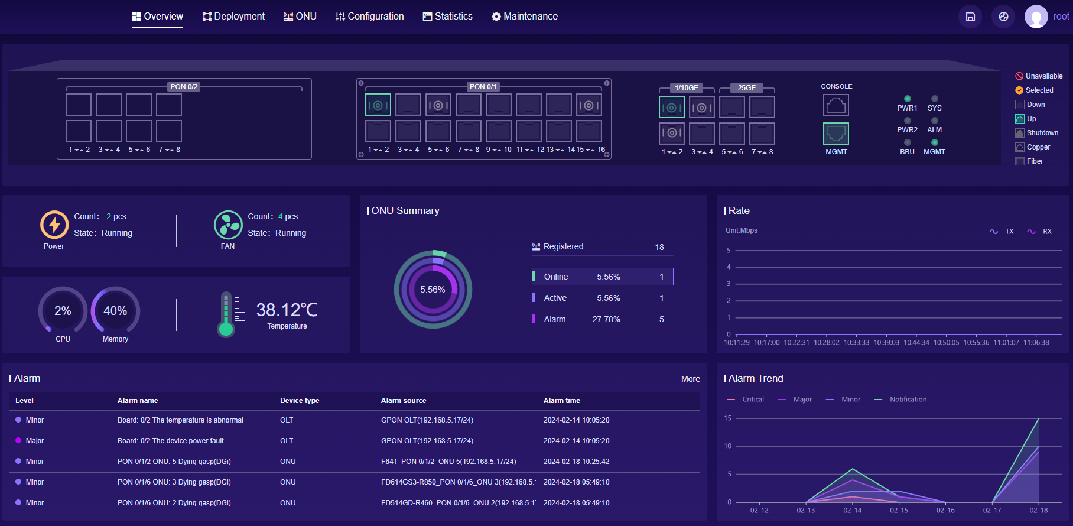

FIG.13 Initial page of OLT Web

* + 1. Creating a VLAN
* Access path: Configuration ----> VLAN---->Port VLAN----> Click the "Edit" button

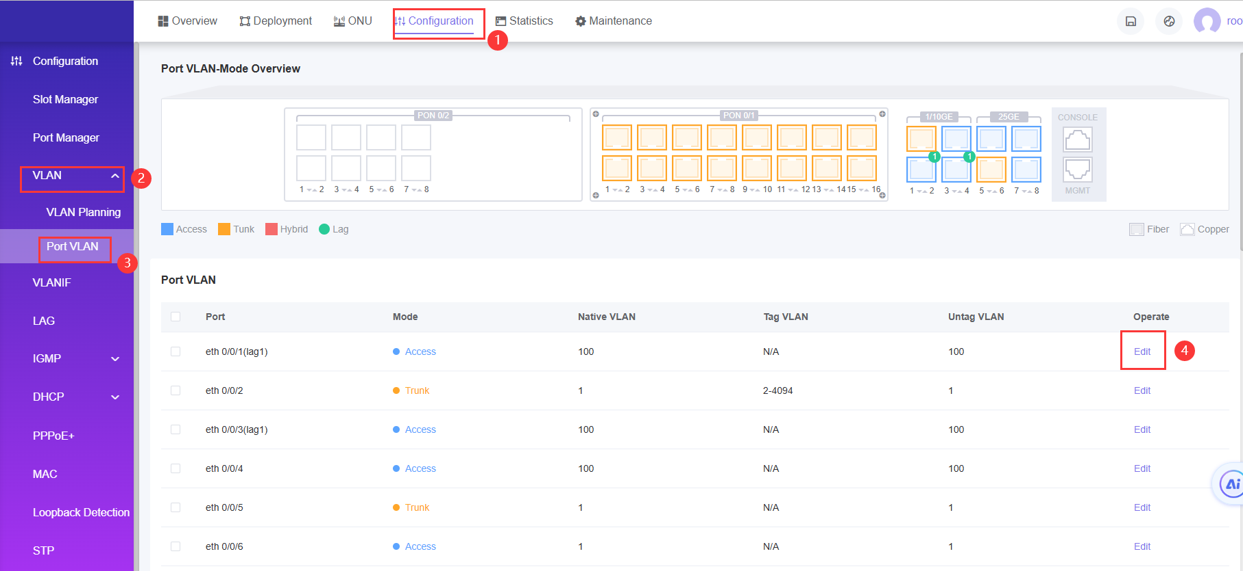

FIG.14 Create VLAN-1

The page brings up a pop-up window to Edit.

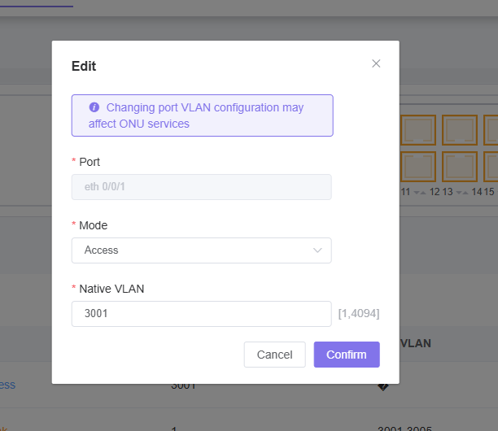

FIG.15 Creating VLAN-2

1. Set the ge port mode ,chooes access mode.

2. Set the VLan you want to config ,here use vlan 3001

Once you're done creating your VLAN, click the "Confirm" button to close the pop-up window.pop-up window.

* + 1. Create ONT DBA Profile
* Access path: Deployment ----> Profile---->DBA Profile ----> Click the "Add" button

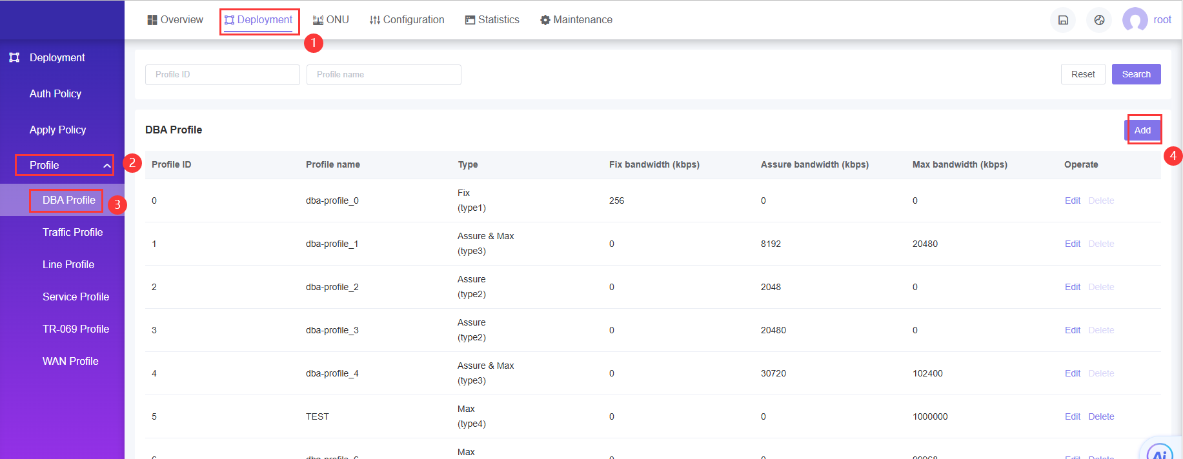

FIG.16 DBA configuration-1

The page brings up a pop-up window to create DBA Profile

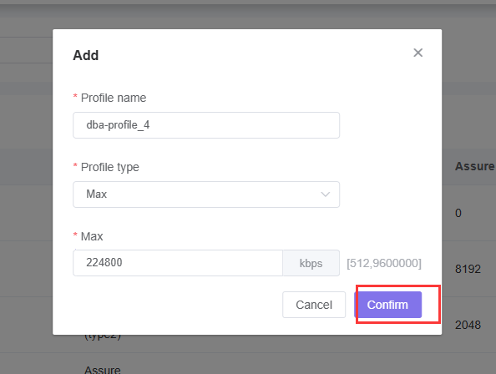

FIG.17 DBA configuration-2

Here, for example, create a DBA template with a max bandwidth of 224800 with the name of 4 and click "Confirm" to create a template.

* + 1. Create ONT Lineprofile
* Access path: Deployment ----> Profile---->Line Profile ----> Click the "Add " button

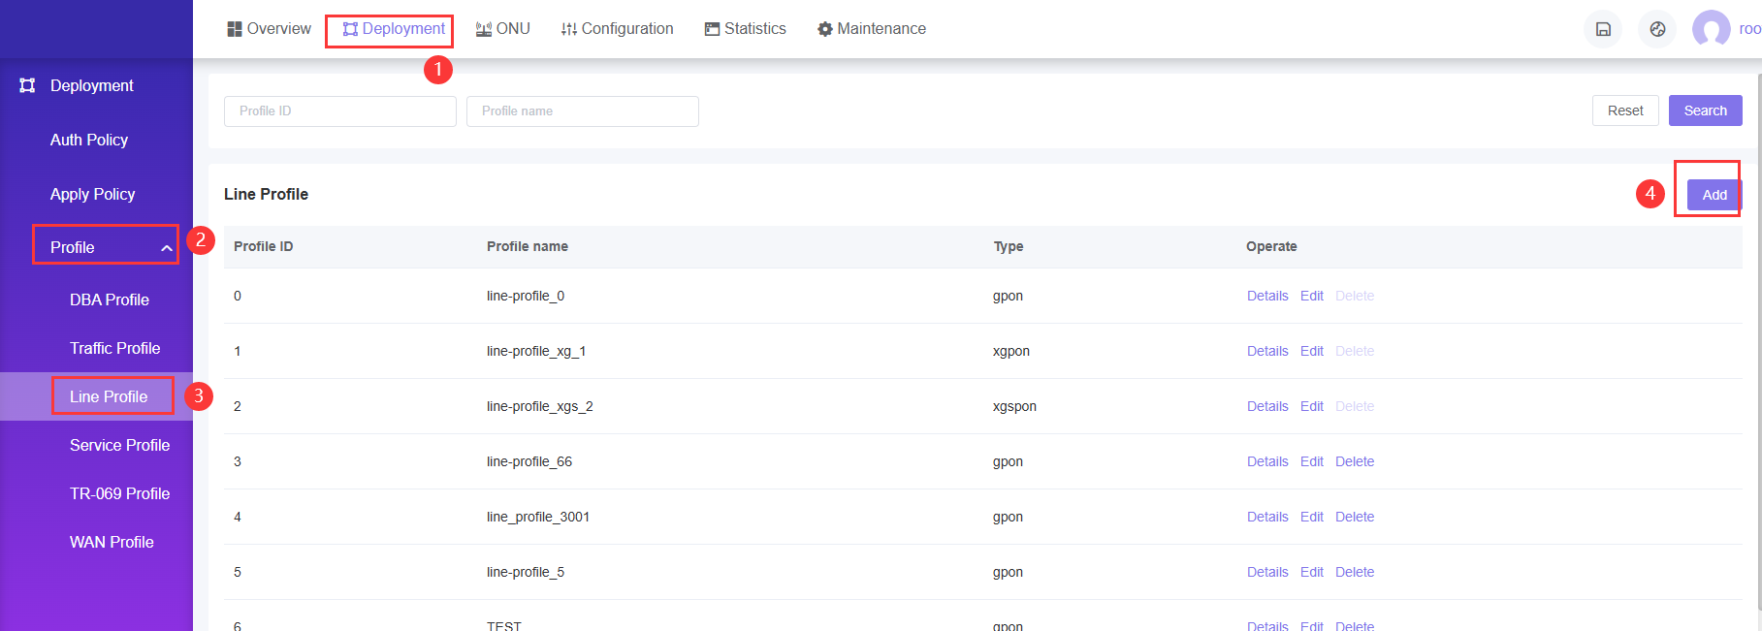

FIG.18 Line configuration-1

The page will skip to anther page to create Lineprofile

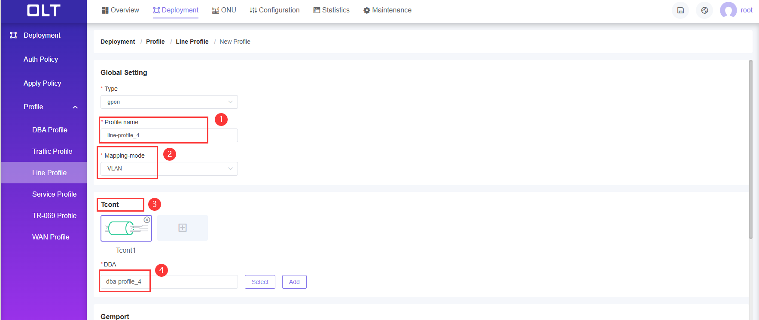

FIG.19 Line configuration-2

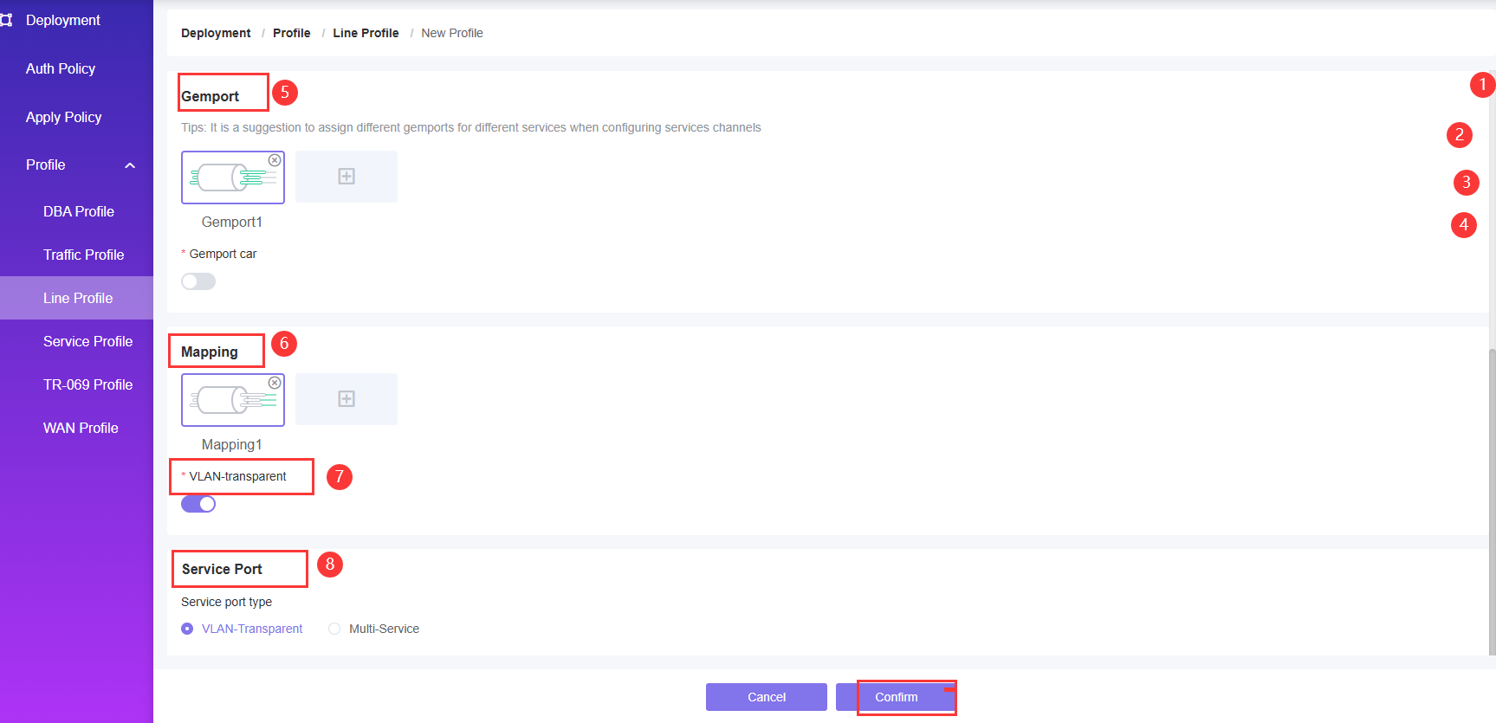

FIG.20 Line configuration-3

1. Take a lineprofile name

2. Select the Mapping mode as VLAN

3. Click the "➕" button, the page will pop up the Add TCONT pop-up box, create the required TCONT, click the "Confirm" button after completion, the pop-up window will close, the start guide to use TCONT1 configuration

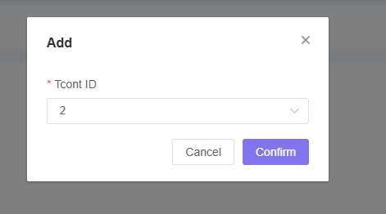

FIG.21 Line configuration-4

4. Click the "Select" button to select the created DBA profile; You can also click the "Add" button, the page will pop up the Add dba profile popup, configure according to the required requirements, click the "Confirm" button after completion, the popup will close. The opening guide is to use dba1 profile.

5. Click "➕" next to Gemport, the page will pop up Add Gempot pop-up box, create different Gemport to host different service, when finished, click "Confirm" button, the pop-up window will close. Start guide to use GEMport id 1

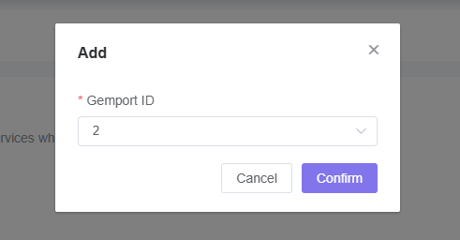

FIG.22 Line configuration-5

6. Create a gem mapping

7. Mapping pass-through is on by default and needs to be turned on

8. Service port type is VLAN-Transparent

Click "Confirm" once you are done with the above configuration

* + 1. Create ONT Srvprofile
* Access path: Deployment ----> Profile---->Service Profile ----> Click the "Add " button

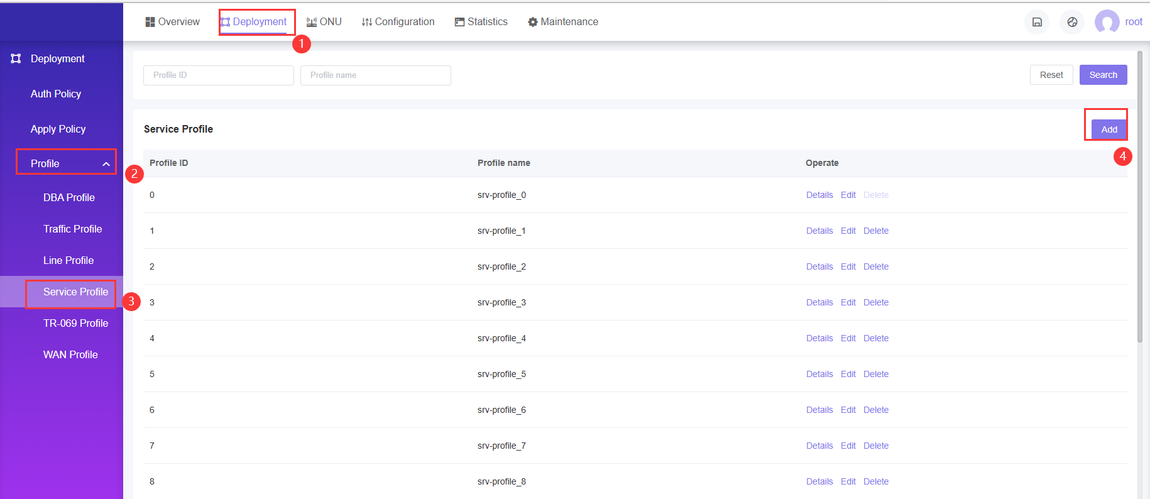

FIG.23 Service configuration-1

The page will skip to anther page to create Srvprofile.

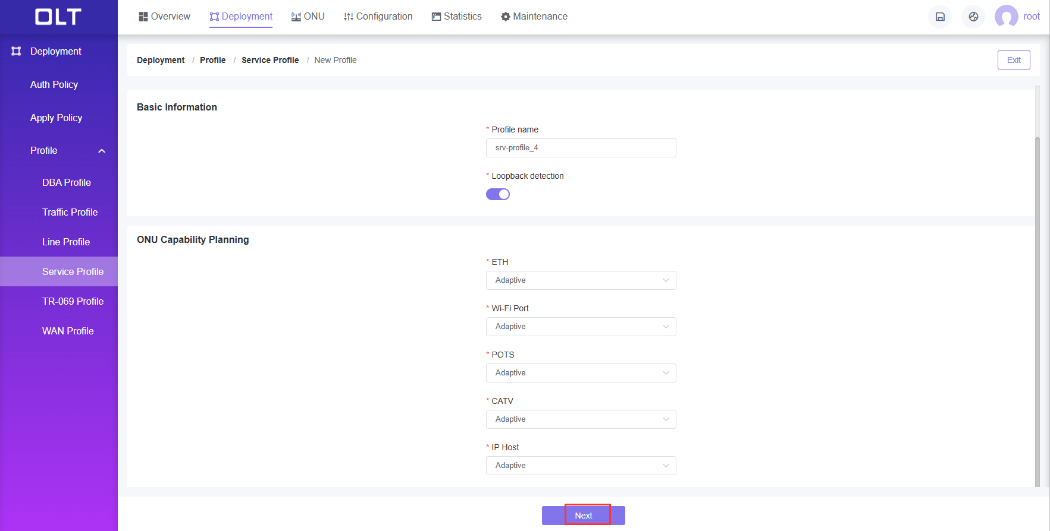

FIG.24 Service configuration-2

The number of ETH number , POTS number ,CATV number and IP Host number configured are adapt.

After you finished,click” Next “button ,The page will skip to IP Host Configuration,In the part ,you can choose not config it .

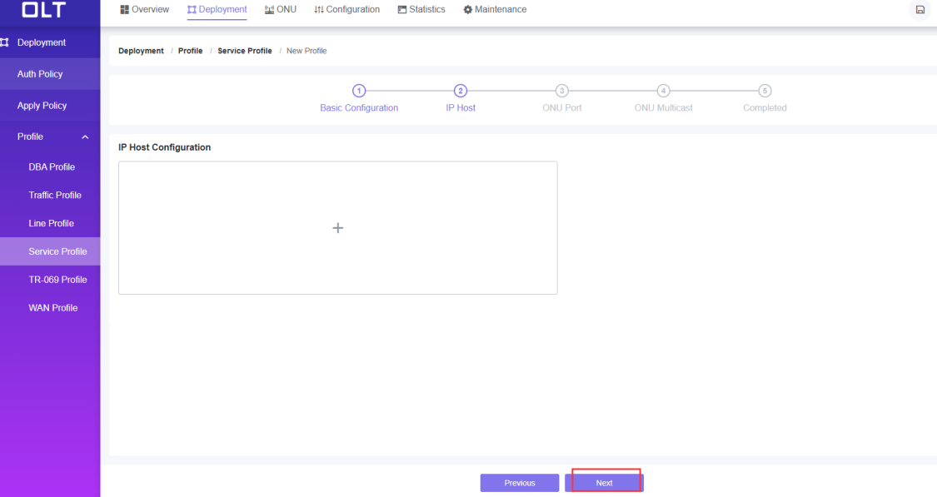

FIG.25 Service configuration-3

Then click” Next “button ,The page will skip to ONU port config,If onu is SFU,you need config it .If it is the HGU,this step is unnecessary.The specific operation is as follows:

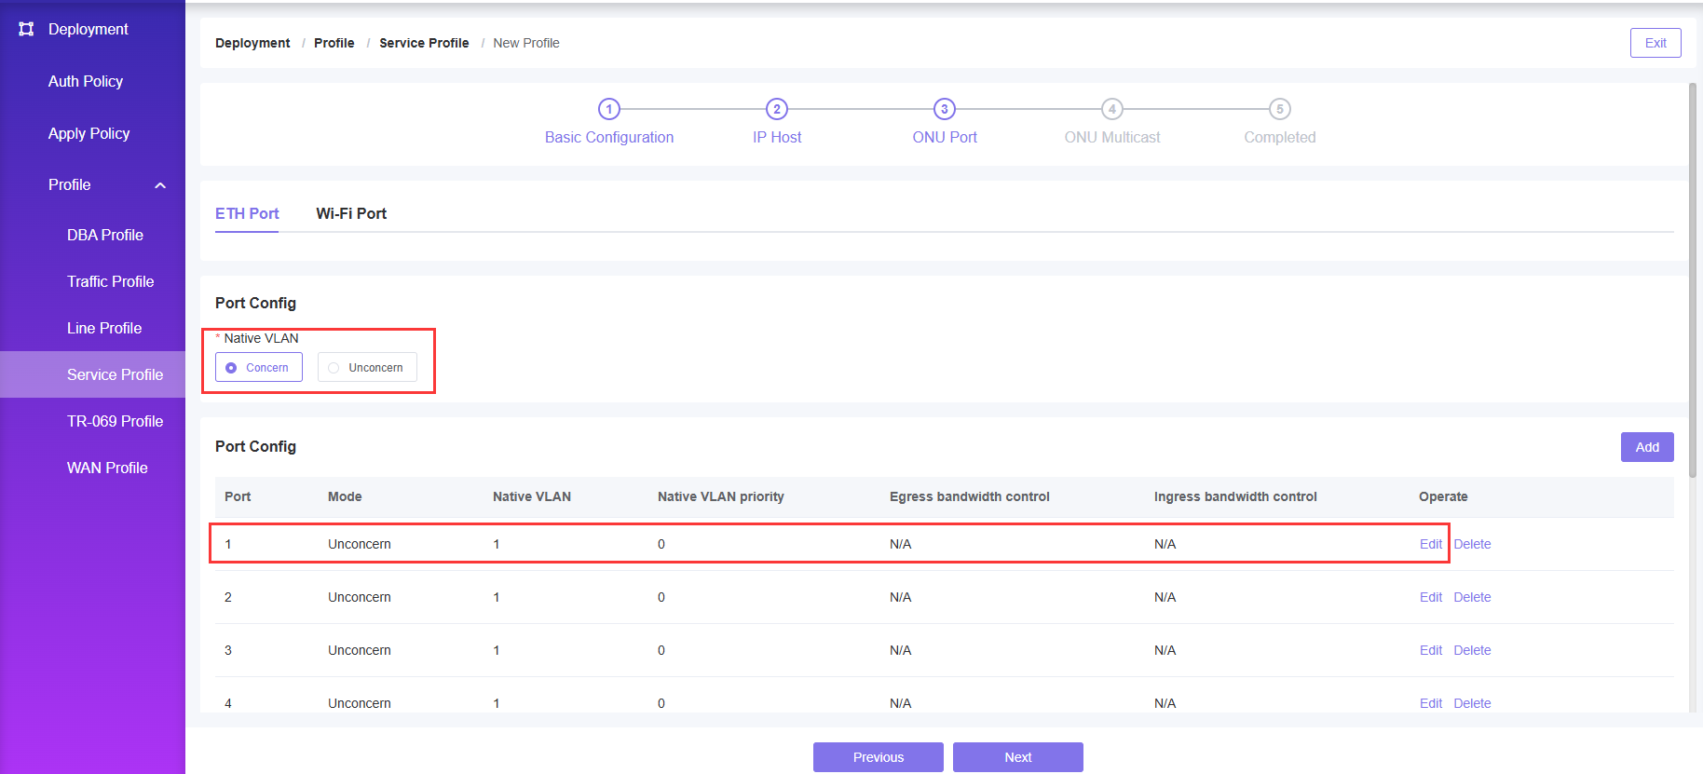

FIG.26 Service configuration-4

1.Native VLAN Click the "Concern" button

2.According the port choose the "Edit" button, the page pops up a window,Enter the Native VLAN, the start guide to use VLAN 3001, select the priority of the Native VLAN according to the needs. Click the "Confirm" button when you are done, and the popup window will close.

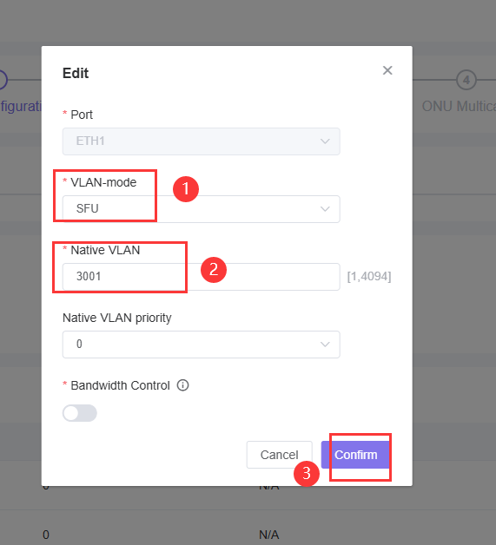

FIG.27 Service configuration-5

3.Click "Next" button, the page will jump to the multicast page, open or close the multicast configuration according to the requirements, do not do any requirements, continue to click "Next", the page will skip, the creation strategy is completed, click "Confirm" button.

* + 1. Create ONT WAN Profile

In this part ,If onu is HGU,you need config it .If it is the SFU,this step is unnecessary.The specific operation is as follows

* Access path: Deployment ----> Profile---->WAN Profile ----> Click the "Add " button

The page will skip to anther page to create WAN Profile

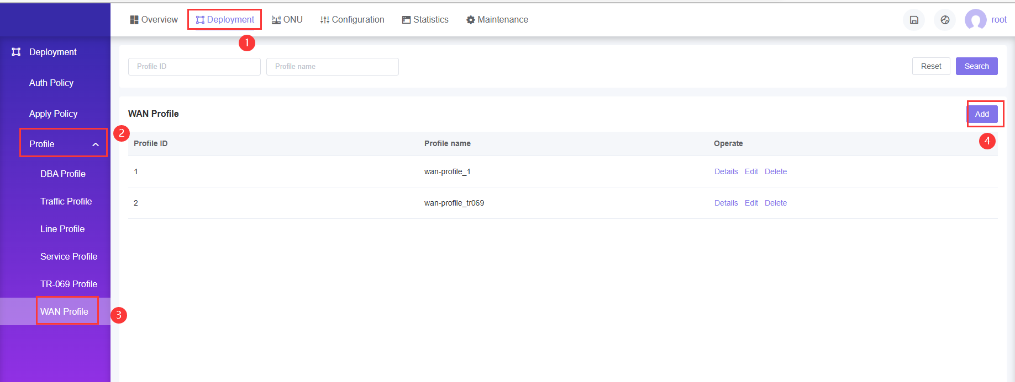

FIG.28 WAN configuration-1

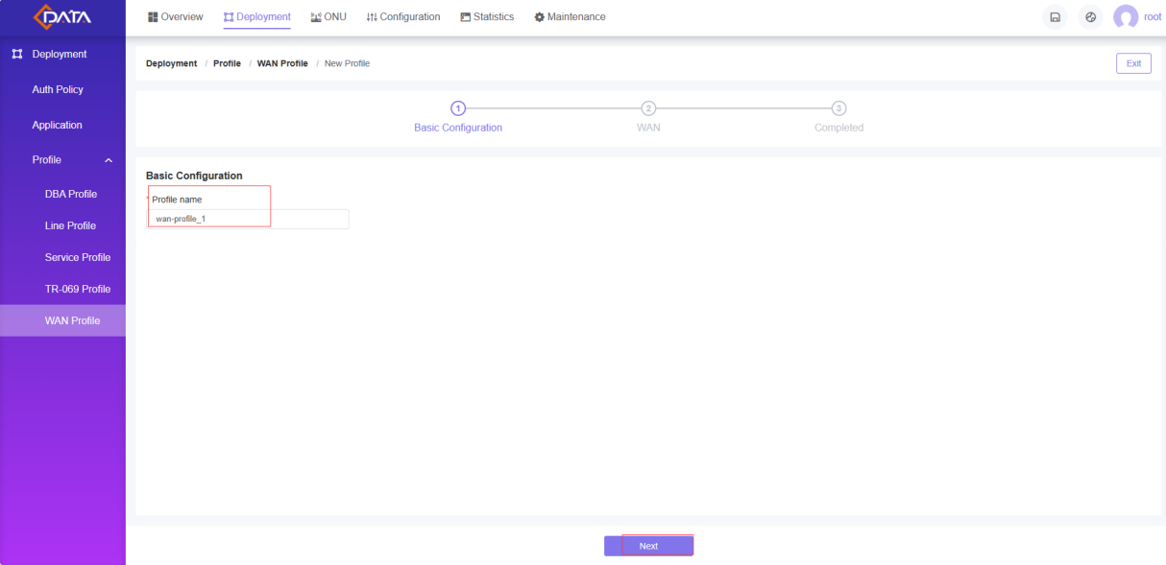

FIG.29 WAN configuration-2

Setting the WAN Profile name ,then click the “next”button,the page skip the follow page

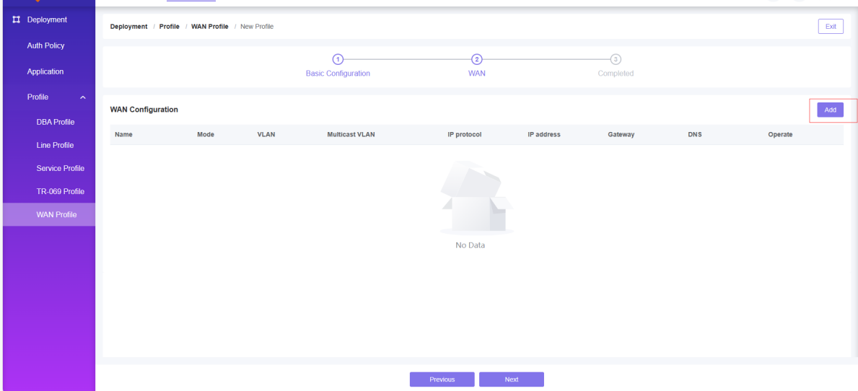

FIG.30 WAN configuration-3

Then click the “Add”button,the page brings up a pop-up window to set WAN parameters

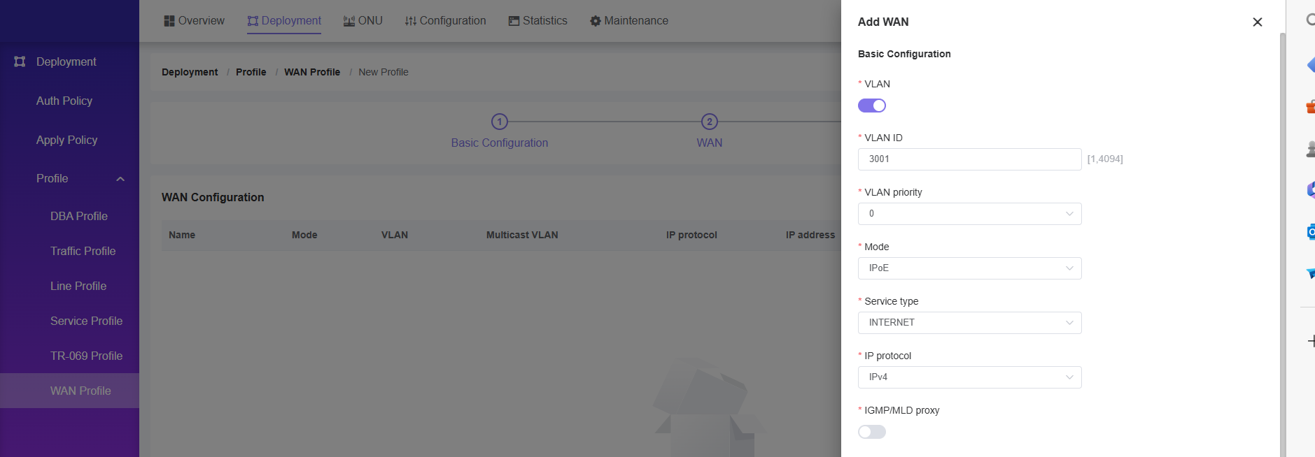

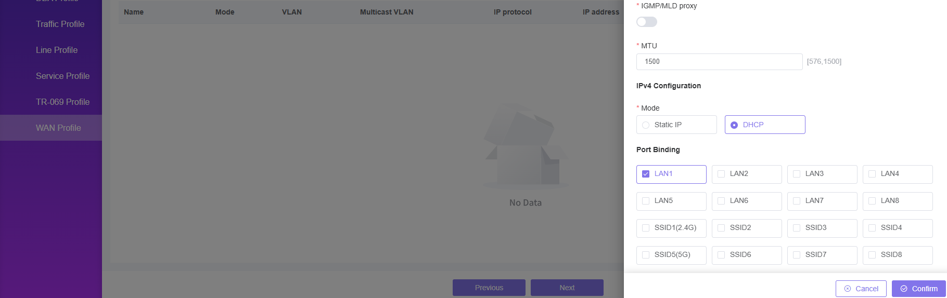

FIG.31 WAN configuration-4

After you finished,click the “Confirm”button ,the pop-up window will be closed.

* + 1. Policy Application

In the GPON/EPON OLT network deployment, a large number of ONU devices need to be deployed, and the related work of deployment and debugging is cumbersome and costly. ONU is easy to deploy, only the ONU deployment strategy needs to be configured in the OLT Web management system in advance, and it is applied to the OLT PON port. When the ONU is online for the first time, the OLT device can automatically detect the online ONU and automatically match with the existing policy. After the match is successful, the OLT device will automatically create and execute the ONU deployment task to complete the ONU plug and play deployment, which greatly improves the deployment efficiency and reduces the cost of network construction.

**Create Policy**

* Access path: Deployment ----> Auth Policy ----> Click the "Create Policy " button

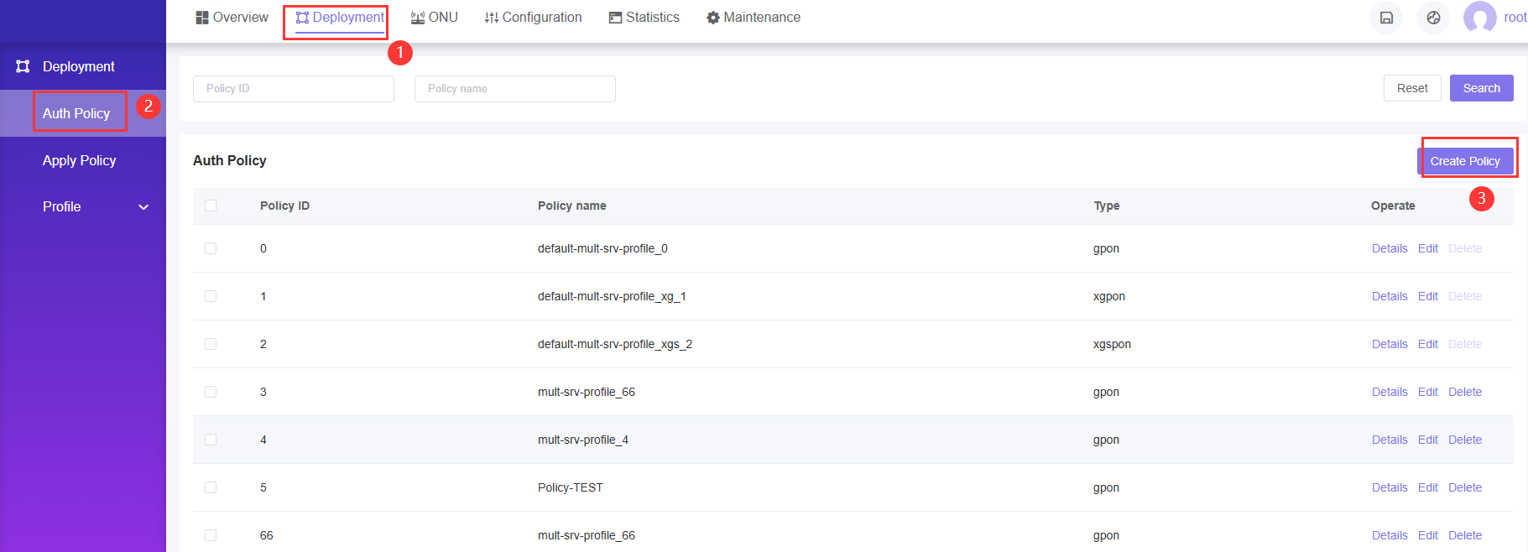

FIG.32 Configuration Application-1

The page will skip to anther page

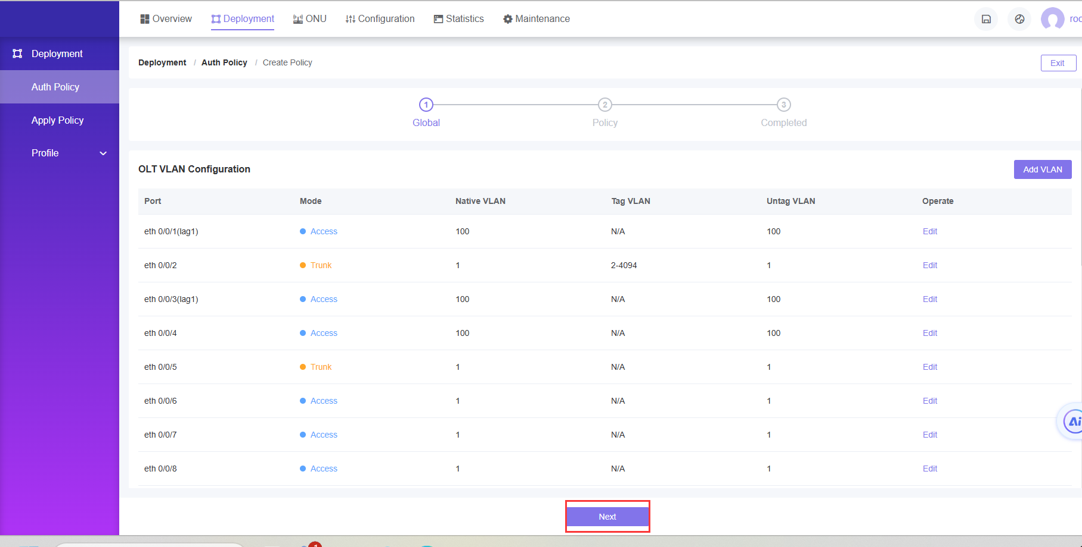

FIG.33 Configuration Application-2

Click “next”button,The page will skip to anther page to choose the profile

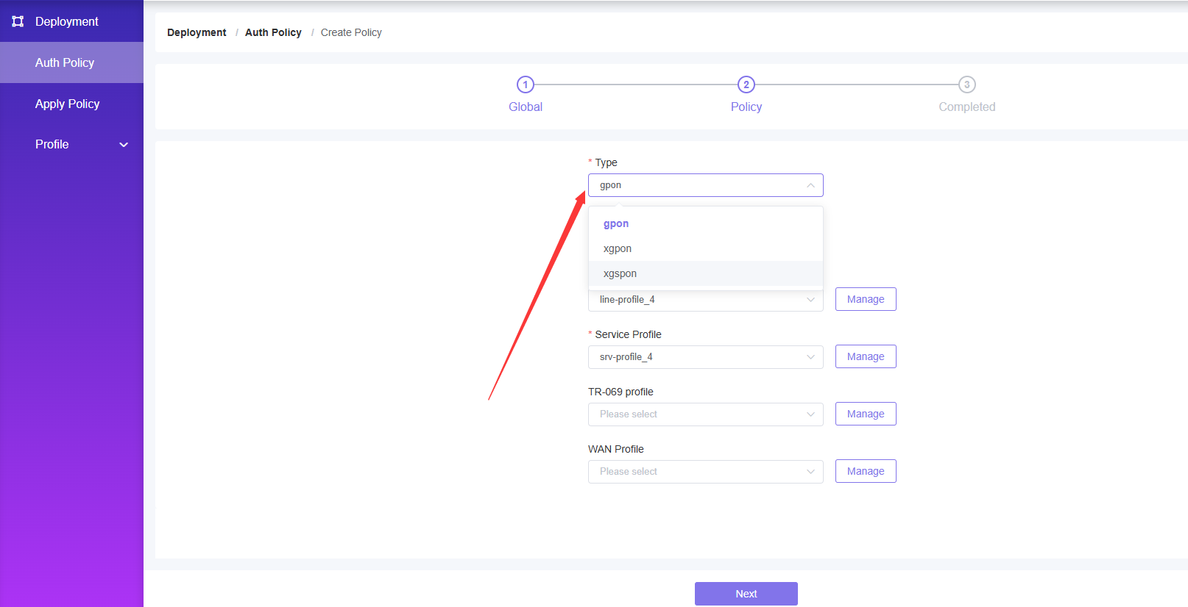

FIG.34 Configuration Application-3

This completes the creation of the policy.

**Note:** GPON and XGSPON are separate here, and corresponding types should be selected. For example, if you want to deploy XGSPON ONU, the type should be XGSPON

**Policy Application**

* Access path: Deployment ----> Apply Policy ----> Click the "Add " button

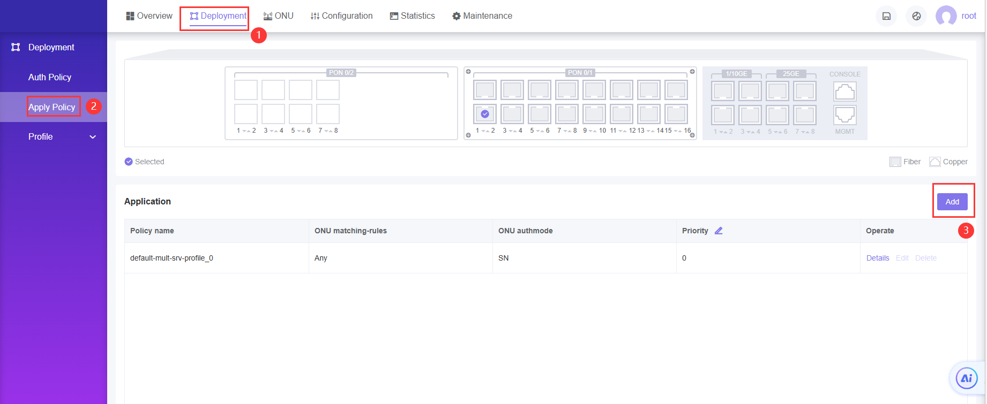

FIG.35 Configuration Application-4

The page brings up a pop-up window.

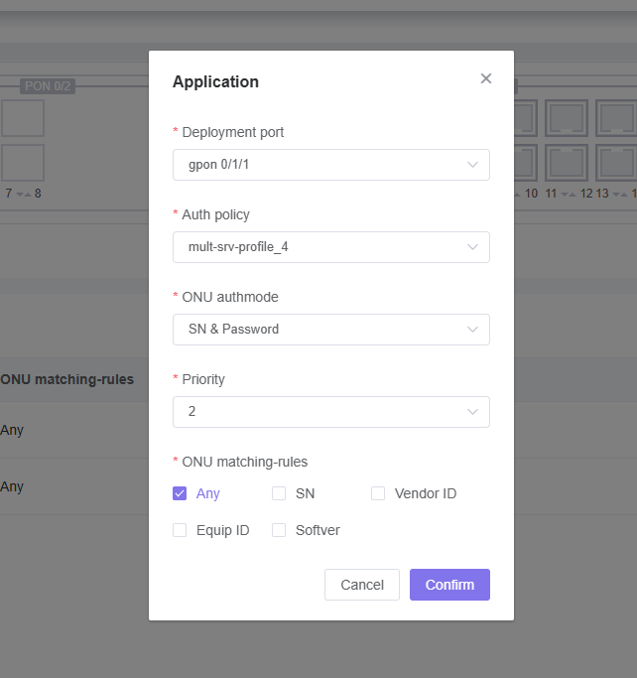

FIG.36 Configuration Application-5

1. Select the PON port where you want to apply the policy application

2. Select ONU Auth Policy

3. Select the ONU's authentication mode

4. Select the policy priority

5. Determine the matching conditions for the ONU

Click the "Confirm" button and the configuration is complete.

**Note:** Check to see if the configuration was successful.

* Access path: Deployment ----> Appy Policy ----> Click the "Details" button

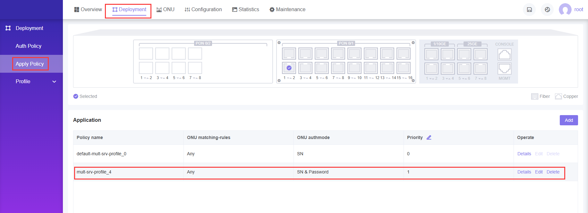

FIG.37 Configuration Application-6

**Note:** The above configuration is a plug-and-play part of the Internet service configuration, configuration application in that PON port, as long as the ONU connected to the PON port can be applied.

* 1. OLT multicast configuration -WEB mode
     1. Data planning

|  |  |
| --- | --- |
| List of key data planning | |
| Configuration items | Specific data |
| OLT Port configuration | GE1: VLAN 3001 access mode |
| DBA profile (Uplink Bandwidth control) | Profile No. : 4 |
| Lineprofile | Profile No. : 4  TCONT ID : 1  GEM Port ID:1 |
| Srvprofile | Profile No. : 4  ONT port Capability set:Adaptive |
| Bridge-type ONT port configuration | LAN1: VLAN 3001 |
| Gateway type ONT port configuration | LAN1: VLAN 3001 |

* + 1. Log in to the OLT web management system

**Prerequisites**

The OLT Web management system adopts B/S architecture, please ensure that the network connection between the current PC and OLT equipment is normal and the OLT equipment is working properly before logging in.

**Background Information**

OLT Web provides four initial users by default, as follows:

Table 14 OLT Web Initial user Table

|  |  |  |  |
| --- | --- | --- | --- |
| User name | Roles | Password | Notes |
| root | Root | admin | This user has all the operation rights of all the objects managed by the OLT Web management system |
| admin | Admin | admin | This user has all the operation rights of OLT Web management system except for user deletion |
| operator | Operator | admin | The user has access and operation rights to common functions of OLT Web management system |
| guest | Guest | guest | This user has access only |

**Log in to the OLT Web management system**

* Enter the out-of-band management IP address (192.168.100.1 by default) or in-band management IP of the OLT device in the browser address bar to access the login page of the OLT Web management system.
* Enter the username and password on the login page and click the "Login" button;
* After the user successfully logs in, the system will jump to the main page of the OLT Web management system, and the typical initial page is shown in the figure



FIG.38 Initial page of OLT Web

* + 1. Creating a VLAN
* Access path: Configuration ----> VLAN---->Port VLAN----> Click the "Edit" button



FIG.39 Create VLAN-1

The page brings up a pop-up window to Edit.



FIG.40 Creating VLAN-2

1. Set the ge port mode ,chooes access mode.

2. Set the VLan you want to config ,here use vlan 3001

Once you're done creating your VLAN, click the "Confirm" button to close the pop-up window.pop-up window.

* + 1. Create ONT DBA Profile
* Access path: Deployment ----> Profile---->DBA Profile ----> Click the "Add" button



FIG.41 DBA configuration-1

The page brings up a pop-up window to create DBA Profile



FIG.42 DBA configuration-2

Here, for example, create a DBA template with a max bandwidth of 224800 with the name of 4 and click "Confirm" to create a template.

* + 1. Create ONT Lineprofile
* Access path: Deployment ----> Profile---->Line Profile ----> Click the "Add " button



FIG.43 Line configuration-1

The page will skip to anther page to create Lineprofile



FIG.44 Line configuration-2



FIG.45 Line configuration-3

1. Take a lineprofile name

2. Select the Mapping mode as VLAN

3. Click the "➕" button, the page will pop up the Add TCONT pop-up box, create the required TCONT, click the "Confirm" button after completion, the pop-up window will close, the start guide to use TCONT1 configuration



FIG.46 Line configuration-4

4. Click the "Select" button to select the created DBA profile; You can also click the "Add" button, the page will pop up the Add dba profile popup, configure according to the required requirements, click the "Confirm" button after completion, the popup will close. The opening guide is to use dba1 profile.

5. Click "➕" next to Gemport, the page will pop up Add Gempot pop-up box, create different Gemport to host different service, when finished, click "Confirm" button, the pop-up window will close. Start guide to use GEMport id 1



FIG.47 Line configuration-5

6. Create a gem mapping

7. Mapping pass-through is on by default and needs to be turned on

8. Service port type is VLAN-Transparent

Click "Confirm" once you are done with the above configuration

* + 1. Create ONT Srvprofile
* Access path: Deployment ----> Profile---->Service Profile ----> Click the "Add " button



FIG.48 Service configuration-1

The page will skip to anther page to create Srvprofile.



FIG.49 Service configuration-2

The number of ETH number , POTS number ,CATV number and IP Host number configured are adapt.

After you finished,click” Next “button ,The page will skip to IP Host Configuration,In the part ,you can choose not config it .



FIG.50 Service configuration-3

Then click” Next “button ,The page will skip to ONU port config,If onu is SFU,you need config it .If it is the HGU,this step is unnecessary.The specific operation is as follows:



FIG.51 Service configuration-4

1. Native VLAN Click the "Concern" button

2. According the port choose the "Edit" button, the page pops up a window,Enter the Native VLAN, the start guide to use VLAN 3001, select the priority of the Native VLAN according to the needs. Click the "Confirm" button when you are done, and the popup window will close.



FIG.52 Service configuration-5

Click "Next" button, the page will jump to the multicast page

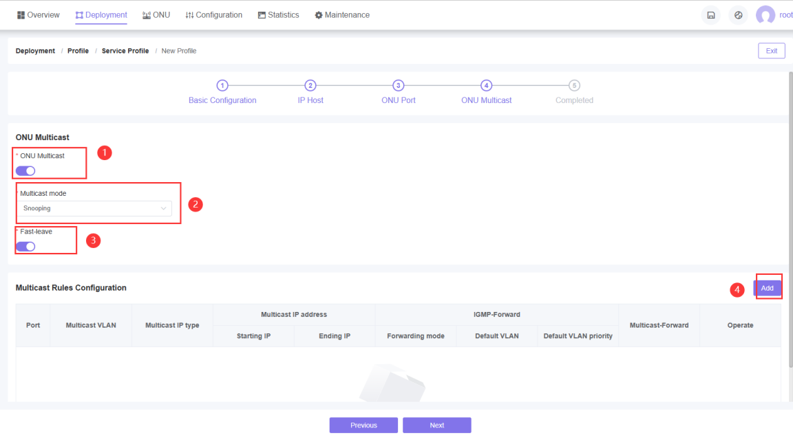

FIG.53 Service configuration-6

1. Click the blue button below "Multicast Configuration" to open the multicast configuration

2. Select "snooping" for multicast mode

3. Click the blue button below "Fast-leave" to turn on Fast-leave

4. Tap the "Add" button. The Add popup window of port Multicast rule configuration appears on the page, fill in the port number of ONU, multicast VLAN ID, type of multicast IP,IGMP-Forward and multicast-forward select transparent, after completion, click "Confirm" button, and the popup window will close.Then click the “Confirm”button to finish the Srvprofile Config .

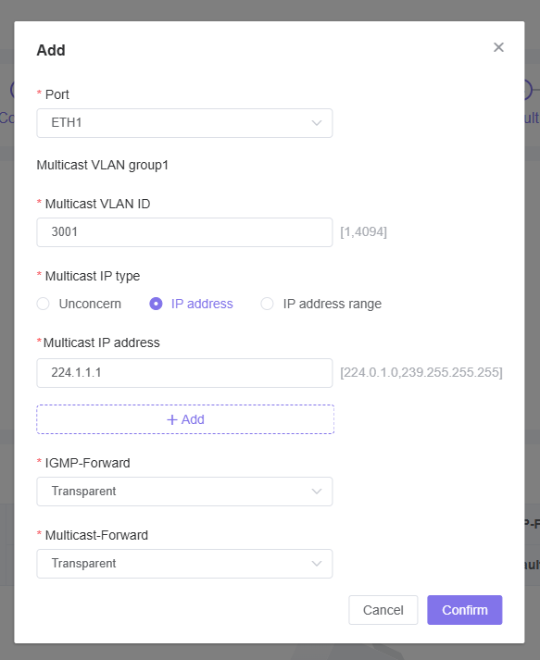

FIG.54 Service configuration-7

* + 1. Create ONT WAN Profile

In this part ,If onu is HGU,you need config it .If it is the SFU,this step is unnecessary.The specific operation is as follows

* Access path: Deployment ----> Profile---->WAN Profile ----> Click the "Add " button

The page will skip to anther page to create WAN Profile



FIG.55 WAN configuration-1



FIG.56 WAN configuration-2

Setting the WAN Profile name ,then click the “next”button,the page skip the follow page



FIG.57 WAN configuration-3

Then click the “Add”button,the page brings up a pop-up window to set WAN parameters





FIG.58 WAN configuration-4

After you finished,click the “Confirm”button ,the pop-up window will be closed.

* + 1. Policy Application

In the GPON/EPON OLT network deployment, a large number of ONU devices need to be deployed, and the related work of deployment and debugging is cumbersome and costly. ONU is easy to deploy, only the ONU deployment strategy needs to be configured in the OLT Web management system in advance, and it is applied to the OLT PON port. When the ONU is online for the first time, the OLT device can automatically detect the online ONU and automatically match with the existing policy. After the match is successful, the OLT device will automatically create and execute the ONU deployment task to complete the ONU plug and play deployment, which greatly improves the deployment efficiency and reduces the cost of network construction.

**Create Policy**

* Access path: Deployment ----> Auth Policy ----> Click the "Create Policy " button



FIG.59 Configuration Application-1

The page will skip to anther page



FIG.60 Configuration Application-2

Click “next”button,The page will skip to anther page to choose the profile



FIG.61 Configuration Application-3

This completes the creation of the policy.

**Note:** GPON and XGSPON are separate here, and corresponding types should be selected. For example, if you want to deploy XGSPON ONU, the type should be XGSPON

**Policy Application**

* Access path: Deployment ----> Apply Policy ----> Click the "Add " button



FIG.62 Configuration Application-4

The page brings up a pop-up window.



FIG.63 Configuration Application-5

1. Select the PON port where you want to apply the policy application

2. Select ONU Auth Policy

3. Select the ONU's authentication mode

4. Select the policy priority

5. Determine the matching conditions for the ONU

Click the "Confirm" button and the configuration is complete.

**Note:** Check to see if the configuration was successful

* Access path: Deployment ----> Appy Policy ----> Click the "Details" button



FIG.64 Configuration Application-6

**Note:** The above configuration is a plug-and-play part of the Internet service configuration, configuration application in that PON port, as long as the ONU connected to the PON port can be applied.

* + 1. IGMP global configuration

Access path: Configuration ---->IGMP----> Global Setting

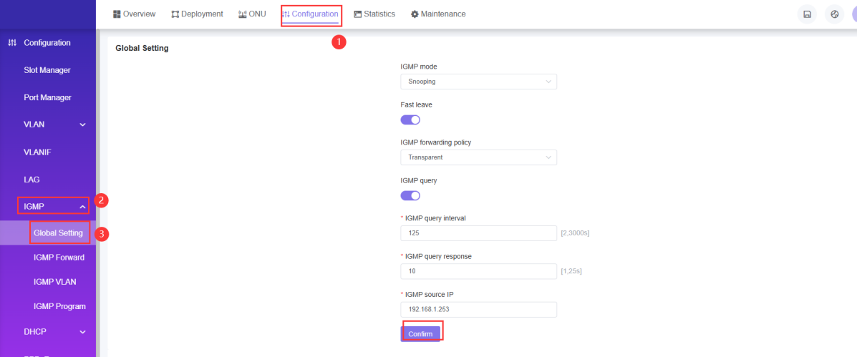

Figure.65 IGMP global configuration

1. IGMP mode is selected as Snooping

2. Tap the button under Fast leave to open Fast leave

3. The forwarding strategy for IGMP is chosen to be pass-through

4. Click the button under IGMP Query to open IGMP Query

5. Enter the IGMP source IP which is the multicast source IP(the ip of the server that is broadcasting the show)

* + 1. Multicast forwarding

Access path:Configuration ---->IGMP----> IGMP Forwarding -----> Click "Add" button, fill in the multicast IP address,VLAN, and member port in turn in the pop-up window, click "Confirm" button after completion, the pop-up window closes.

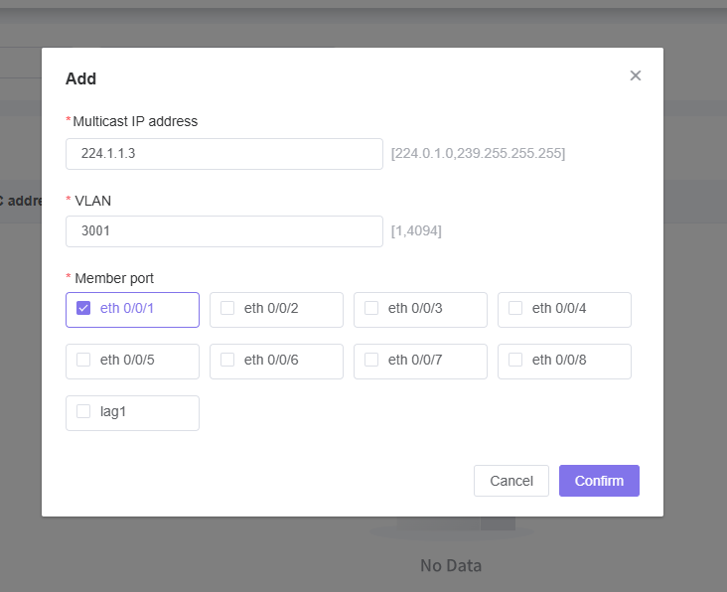

FIG.66 Configuration of multicast forwarding

* + 1. Multicast VLAN configuration

Operation path: Configuration ---->IGMP----> IGMP VLAN----> Click "Add" button, the page pops up multicast VLAN add popup window

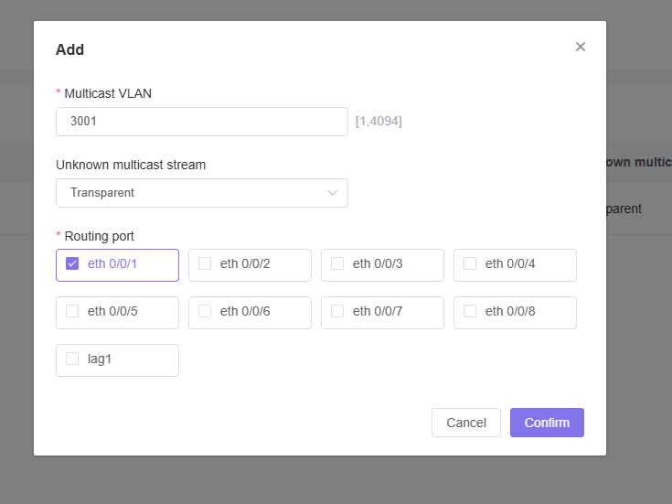

FIG.67 Multicast VLAN configuration

* + 1. Multicast VLAN program added

Operation path: Configuration ---->IGMP----> IGMP Program ----> Click "Add" button, the page will pop up multicast VLAN program add popup window

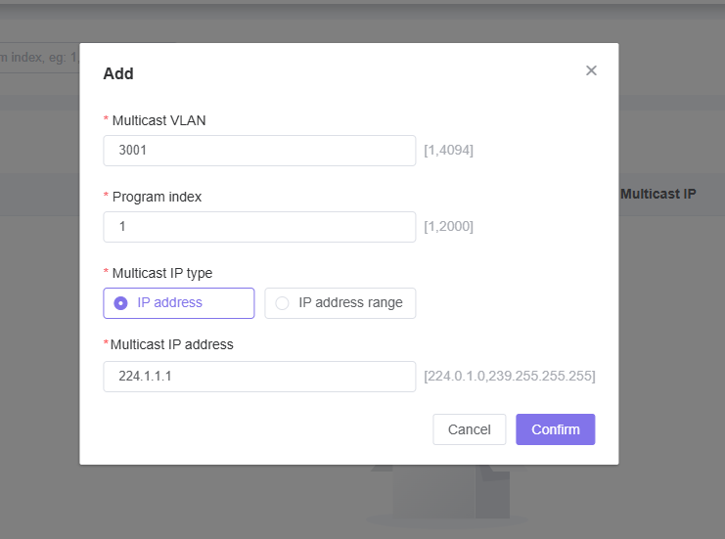

Figure.68 Multicast VLAN program add