****

**CMS User Manual**

**Cloud Management System**

**Product Description**

**Product Version：V0.7**

**Shenzhen C-Data Technology Co.,Ltd.**

Address: 2nd Floor, Building A4, Nanshan Zhiyuan,

1001 Xueyuan Avenue, Nanshan District,

Shenzhen, China

Website: www.cdatatec.com

Email: support@cdatatec.com

**Copyright Reserved**

Without the prior written consent of C-DATA, any reproduction, excerpting, backup, modification, translation or any other form of commercial use of this document or any portion of this document, and in any form or by any means, to transmit the document are prohibited.

**Trademark Declaration**

**IMG_256**is a trademark or registered trademark of C-DATA and its affiliates. Without the prior written consent of C-DATA , no entity or individual may use, copy, modify, disseminate or bundle any part of the trademark, trade name or logo of C-DATA in any way or reason.

All other trademarks, product names, service names and company names mentioned in this document and mentioned in the products described in this document are the property of their respective holders.

**Disclaimer**

The information in this document is made based on the existing information and may be verified at any time due to product upgrade or any other reasons. We reserve the right to alter, modify or otherwise change in any manner the content hereof, without obligation of C-DATA to notify any person of such revision or changes. This document is for reference only.

C-DATA endeavors to ensure content accuracy and will not assume any responsibility for losses and damages caused due to content omissions, inaccuracies or errors. All statements, information, and recommendations in this document do not constitute a warranty of any kind, express or implied.

**Note**

The asterisk (\*) in this article indicates that the feature has not been implemented yet and will be launched in subsequent versions.

**Revision History**

|  |  |  |
| --- | --- | --- |
| Version | Issue Date | Update Description |
|  |  |  |

**Contents**

[Part I Software Introduction 4](#_Toc15502)

[1. Core Strengths 4](#_Toc26247)

[2. Deployment Methods 5](#_Toc1440)

[Part II Deployment 6](#_Toc127)

[Part III Core Features 8](#_Toc14804)

[1. Dashboard 8](#_Toc14509)

[2. Device 9](#_Toc390)

[2.1 Add ONU 10](#_Toc17658)

[2.2 ONU List 10](#_Toc5650)

[2.3 ONU - Device Details 12](#_Toc12318)

[2.4 Configuration 13](#_Toc23280)

[2.5 Data Model 13](#_Toc19657)

[2.6 Topology 14](#_Toc18625)

[2.7 Provisioning 15](#_Toc9988)

[2.8 Batch Config 16](#_Toc427)

[2.9 OTA Upgrade 17](#_Toc3473)

[3. Alarm 18](#_Toc25021)

[3.1 Real-Time Alarm 18](#_Toc23380)

[3.2 Alarm Analysis 19](#_Toc13095)

[3.3 Diagnose 19](#_Toc10515)

[4. Monitor 21](#_Toc11665)

[5. Admin 21](#_Toc4612)

[5.1 Enterprise 21](#_Toc24792)

[5.2 Users 22](#_Toc18948)

[5.3 Domain 23](#_Toc28405)

[5.4 Log 23](#_Toc31352)

[Part IV Q&A 25](#_Toc21980)

**Part I** **Software Introduction**

This part contains the following topics:

* Core Strengths
* Deployment Methods

CMS (Cloud Managed System) is a cloud-based management system launched by C-Data, covering planning, deployment, operation, and optimization to support the full lifecycle of network management. Designed for small and medium-sized operators, CMS provides unified network management for transmission, access, and IP devices. It also offers a range of capabilities for visualized management, and simplified operation.

Currently, CMS only supports certain models of C-Data ONU series. However, in the future, it will gradually support the unified management for all C-Data devices includes switches, OLT, MDUs, routers, and so on.

Our goal is to achieve multi-vendor and multi-product management, provide integrated management and maintenance solution, which includes centralized device management, visual monitoring, and intelligent operation analysis and more. These measures are designed to enhance the efficiency of network planning, deployment, and operation, while reducing service costs, and optimizing resource utilization for operators.

## **Core Strengths**

|  |  |
| --- | --- |
| **Data Dashboard - Visual Management**   * Equipment Distribution - Global Topology Distribution * Equipment Distribution - Geographical Location Distribution Based on GIS\* * Operational Overview - Trend of Newly Added and Active Equipment * Quality Overview - Network/Site Health Assessment\* * Quality Overview- Alarm Statistics and Analysis | **Equipment Management - Unified Network Management Center**   * Topology Structure - Intuitively Display Equipment Hierarchy Relationships * Asset Center - Support Multiple Types\* * Monitoring - Real-time Online Viewing of Equipment Status * Configuration - Support WAN/LAN and Other Common Configurations and Data Models * Configuration - Support Pre-configuration and Batch Configuration * Upgrade - Support Batch OTA Upgrade |
| **Monitoring and Alarm - Simplify Operation and Maintenance**   * Real-time Detection - High/Medium/Low-Risk Alarms * Intelligent Analysis - Attribution Analysis * Fault Diagnosis - Process-based Automatic Detection * Performance Monitoring - Focus on Core Index Changes | **System Management - Improve Efficiency**   * Network Planning and Management * User Role Authorization * Multi-Tenancy\* |
| **High Scalability and Security**   * APP Control\* * Northbound Interface\* * Support Horizontal Expansion, Meet Unlimited Device Access\* * Support TR-069 Protocol, MQTT Protocol\* * Support Linux\* * Support Data Backup\* | **Minimalistic Interaction Experience**   * One-Click Installation * Simplified Configuration and Operation with Professional Requirements Reduction * Minimalistic Visual design |

## **Deployment Methods**

|  |  |
| --- | --- |
| **Private Deployment** | **SaaS Deployment**\* |

**Part II** **Deployment**

This part contains the following topic:

* Three steps to complete CMS installation and deployment.

**Step 1 Set up the Environment**

Set up the environment, including supported operating system and matched server configuration.

* **Operating System**

Support Windows 10 - 64-bit - 22H2, Win11 - 64-bit, Win server 2008 - 64-bit;

Support Linux\*.

* **Server Configurations**

Support horizontal expansion and unlimited device access. It can be configured based on the scale of managed devices. Please refer to the following:

|  |  |  |  |
| --- | --- | --- | --- |
| **Device Scale** | **CPU** | **Memory** | **System Disk Capacity** |
| 30,000 | 4 core | 8G | 500G |
| 60,000 | 8 core | 16G | 500G |
| 100,000 | 12 core | 16G | 500G |
| ... | ... | ... | ... |

**Step 2 Installation Guide**

Run the CMS installer provided by C-Data sales staff and follow the guide to complete the installation process.

|  |  |  |
| --- | --- | --- |
| 1. Double-click the installation package to open the installer; | 2. Click "More Info" and select "Still Run"; | 3. After the installation is completed, the CMS application icon will be on the desktop. |

**Step 3 CMS Start-Up**

Run the CMS program to start the service.

|  |  |  |  |
| --- | --- | --- | --- |
| 1. Double-click on the CMS application icon to open CMS Panel; | 2. Click "Start" to start the CMS service; | 3. After starting, click "Open Web" to open the Enterprise Initialization pop-up box; | 4. Fill in the enterprise initialization information and click "Confirm" to open the web login interface. |

**Part III** **Core Features**

This part contains the following topics:

* Dashboard
* Device
* Alarm
* Monitor
* Admin

The system’s functional architecture is as follows:

|  |  |  |  |  |
| --- | --- | --- | --- | --- |
| **CMS(Cloud Managed System)** | | | | |
| |  | | --- | | **Dashboard** |  * Domain Topology * Total Number of Devices * Device Addition Trend * Network/Site Health\* * Alarm Trend | |  | | --- | | **Device** |   **ONU**   * ONU Add * ONU List/Details * Service Configuration * Data Model   **OLT, Switch... \***  **Domain Topology**  **Pre-configuration**  **Batch Configuration**  **OTA Upgrade** | |  | | --- | | **Alarm** |  * Real-Time Alarms * Alarm Analysis * Fault Diagnosis | |  | | --- | | **Monitor** |  * Monitoring Management | |  | | --- | | **Admin** |  * Enterprise Information * Domain Management * User Authorization * System Log |

**1. Dashboard**

The Dashboard interface mainly consists of a left-side device data panel, a right-side alarm data panel, and a domain topology in the center.

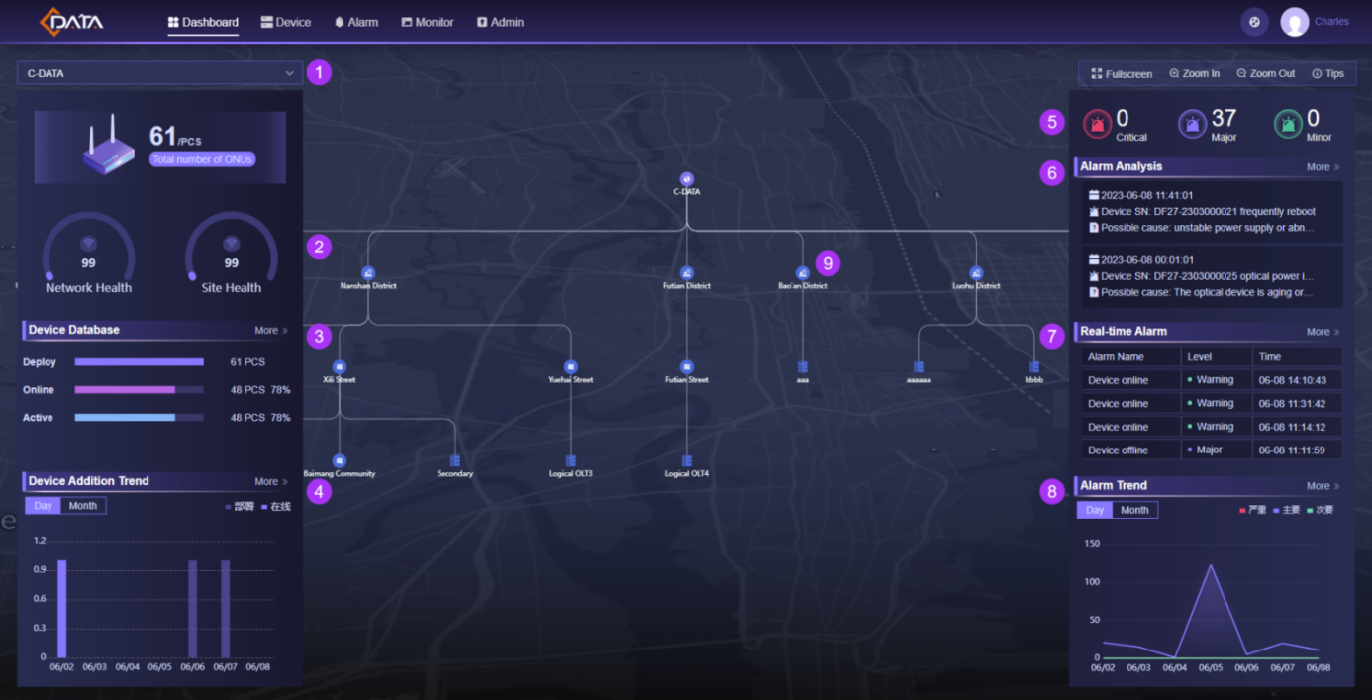

Main Window Introduction:

1. Domain Classification: Allow switching between domain classification, which updates the left and right data panels accordingly and the middle domain topology display the corresponding data;
2. Health Display\*

* Network Health: Indicates to the health status of various devices, such as routers, switches, firewalls, etc.;
* Site Health:Indicates to the health status of communication devices deployed at the site;

1. Device Database

* Deploy: Displays the number of devices automatically added, excluding devices in the recycle bin;
* Online: Displays the number of devices that are currently online among deployed devices;
* Active\*: Displays the devices in use among the online devices;

1. Device Addition Trend: View the number of newly added devices in the last 7 days/month;
2. Total Alarms: Count the total of Critical, Major, and Minor alarms;
3. Alarm Analysis: Intelligent analysis of alarm data, such as early warning of power outage in specific areas, or the aging of optical devices, etc.;
4. Real-Time Alarm: Displays real-time alarm information for devices;
5. Alarm Trend: Displays the quantity trend of Critical, Major, and Minor alarms in the last 7 days/month;
6. Domain Topology: Displays the deployment topology structure of devices;

* Click on the domain icon to display the current domain details;
* Double-click on the domain icon to switch to the current domain data;
* Double-click in the blank area to switch between normal/full-screen modes.

**2. Device**

**2.1 Add ONU**

ONU adding includes the following 3 steps:

1. Upgrade to the new version: CMS supports dual-band ONU models. Please upgrade the ONU to version 3.1.0 or above;

2. Configure the ACS parameters: Turn on the TR-069 switch, fill in the ACS channel address, port, authentication username, and password, etc. The specific info can be found in the [Admin - Enterprise] interface shown below:

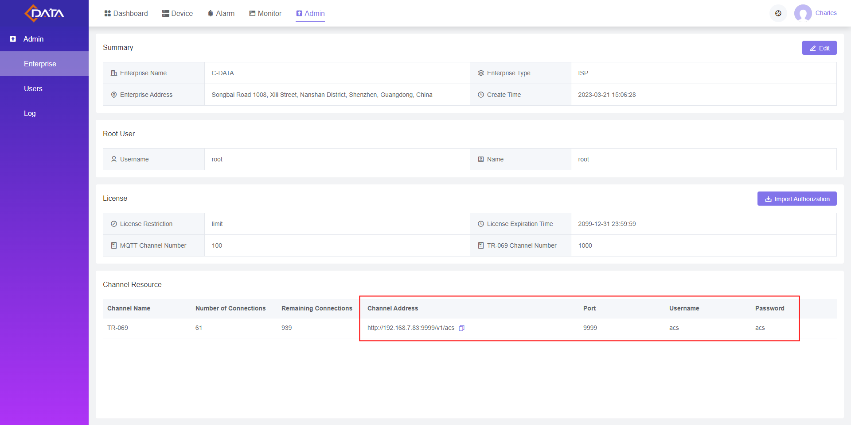

3. The device will be displayed in the ONU list after the Inform report.

**2.2 ONU List**

Click [Device - ONU] menu to enter ONU list interface as shown below, which includes card mode and list mode.

**Card Mode:**

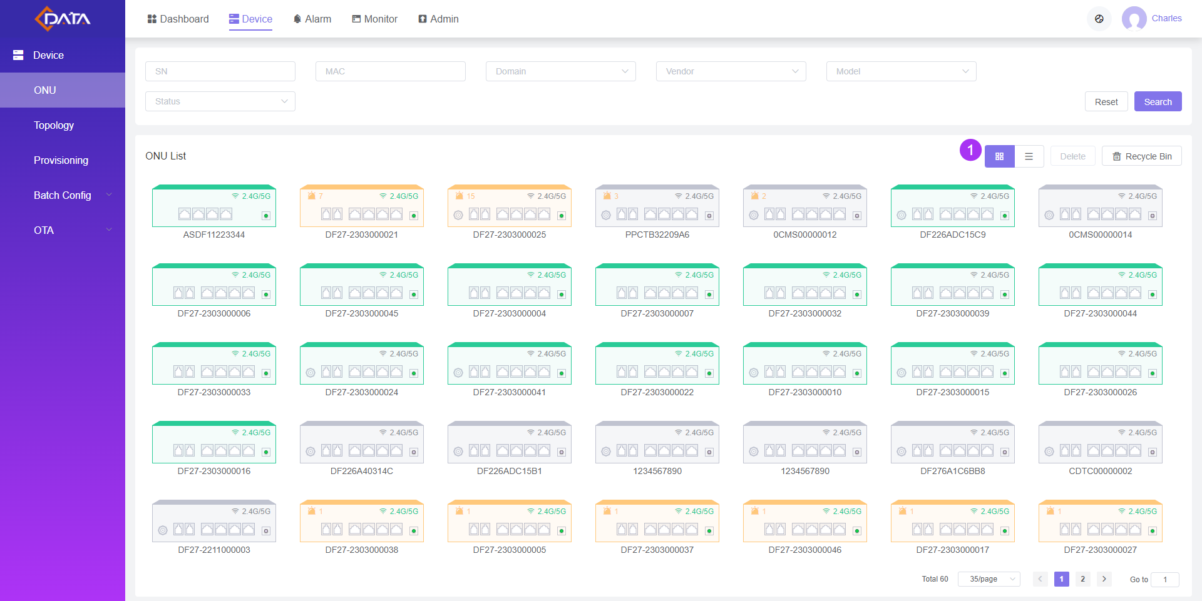

1. Allow switching between card mode and list mode. Click on a card to display the basic information panel, while double-click on a card to open the details page.

**List Mode:**

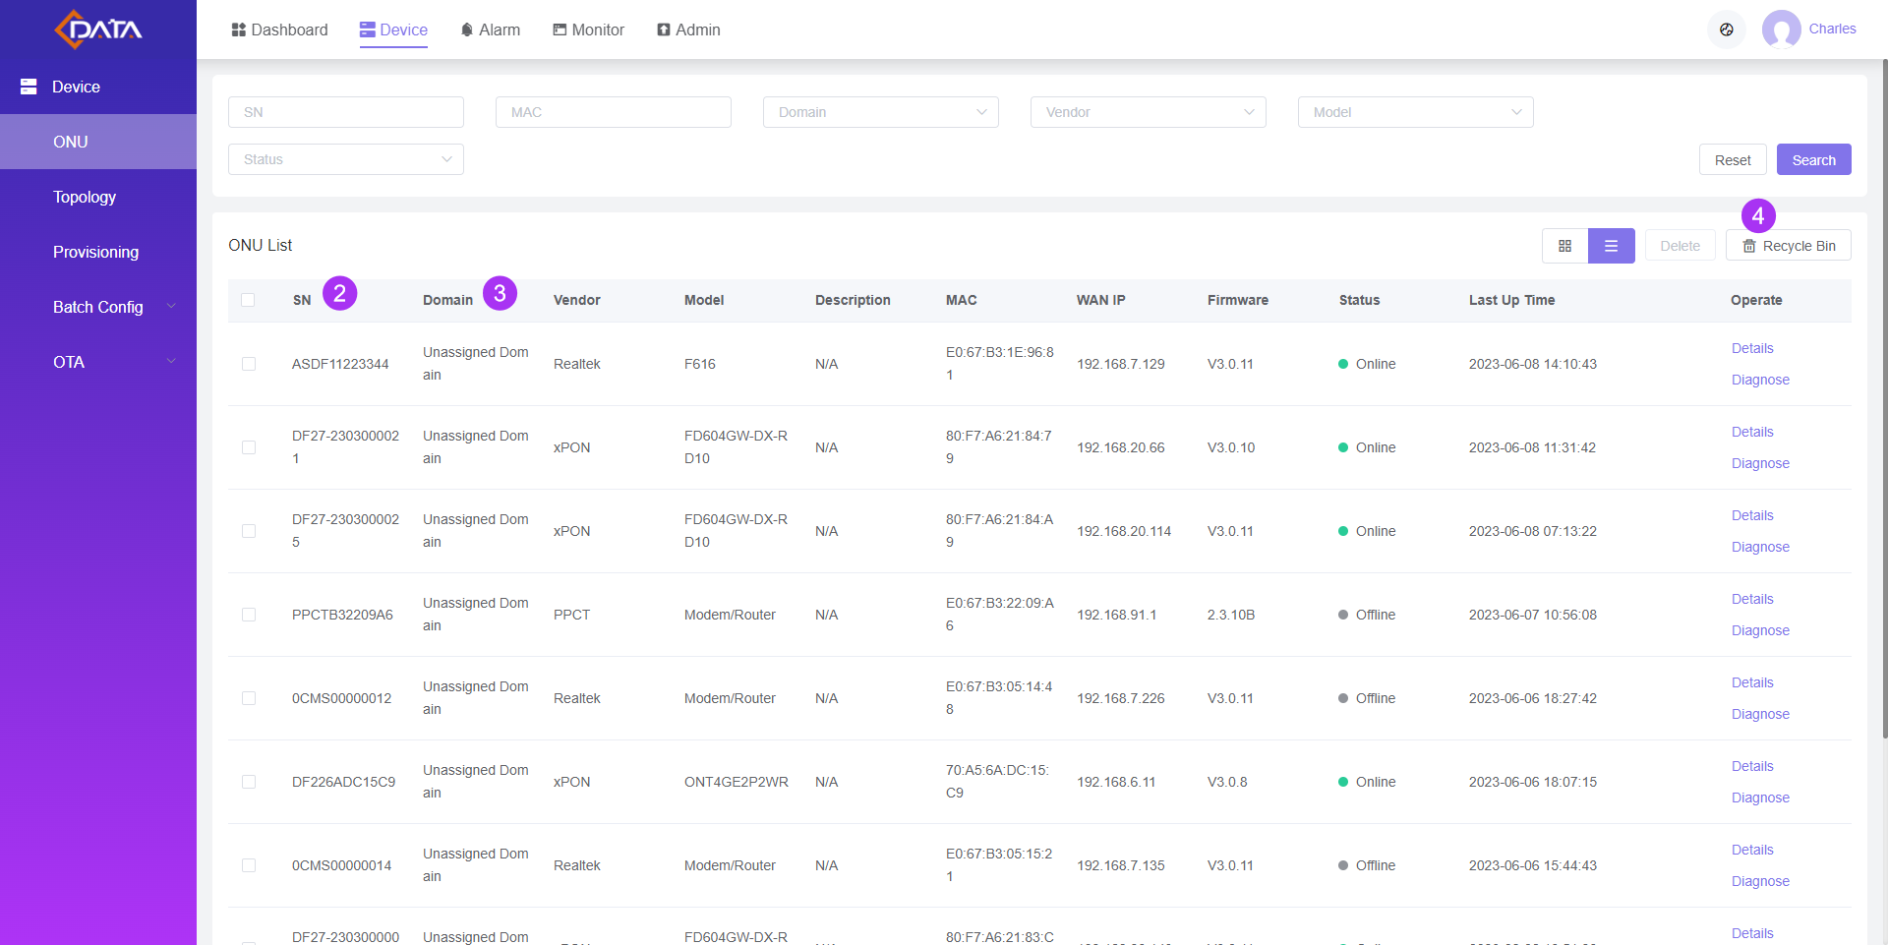

2. SN: For GPON, the SN is the PON SN. For EPON, the SN is the serial number. For third-party devices, the info is based on the data reported by the device;

3. Domain: After the device is added, the domain location is set to "Unassigned Domain" by default and can be batch modified in the [Topology] menu;

4. Recycle Bin: Devices that have been deleted will be sent to the Recycle Bin, and you can "restore" or "permanently delete" the device. The TR-069 channel of a device that has been permanently deleted will be set to empty.

**2.3 ONU - Device Details**

In the ONU list interface, double-click on a device card, double-click the list row or click "Device Details" in the action bar to open the Device Details interface, which is displayed as shown below.

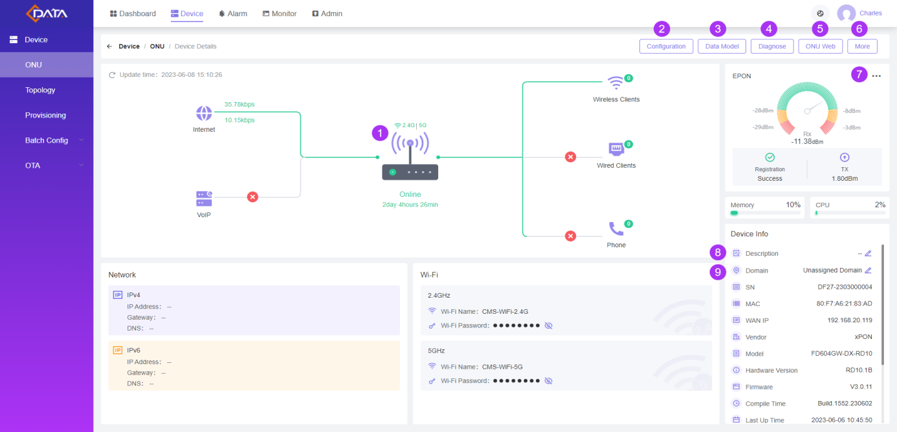

Main Window Introduction:

1. Capability Set: Hover over the ONU area, click on the network, Wi-Fi icon and etc. to view detailed information;

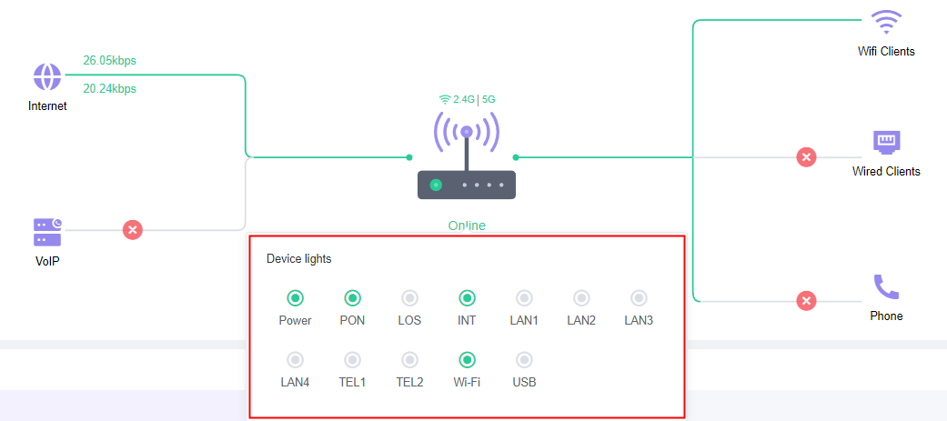

2. Configuration: Configure common services such as WAN/LAN/Wi-Fi/VoIP;

3. Data Model: View and modify all node attributes of the device;

4. Diagnosis: Automatically diagnose device faults;

5. ONU Web: Currently only supported for opening through the LAN and third-party devices are not supported;

6. More: Restart or restore factory settings;

7. PON Card: Click to view voltage, bias current, temperature, etc.;

8. Description: Click to edit the device description information;

9. Domain: Click to select the domain information where the device is located.

**2.4 Configuration**

In the ONU Device Details interface, click the "Configuration" button to enter the following interface. Switch between the WAN/LAN/Wi-Fi/VoIP tabs to configure accordingly.

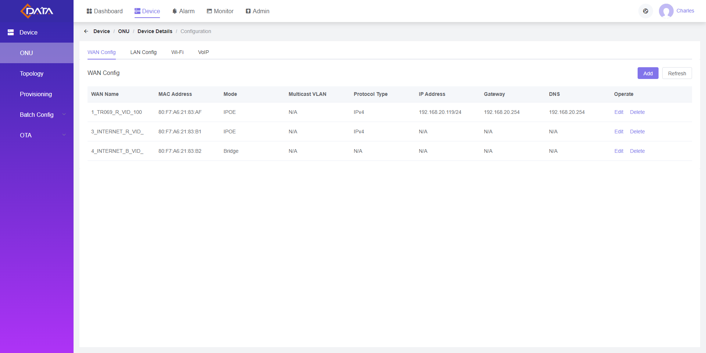

Note: For third-party devices, the corresponding configuration items will be hidden due to the lack of some TR-069 nodes.

**2.5 Data Model**

In the ONU Device Details interface, click the "Data Model" button to enter the following interface. Parameter nodes can be searched and modified directly.

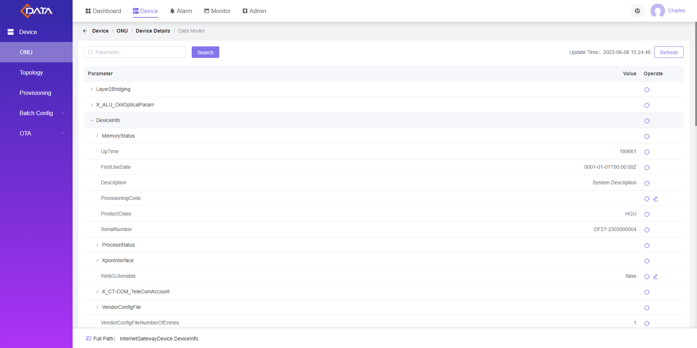

**2.6 Topology**

Click the [Device - Topology] menu to enter the domain topology interface as shown below.

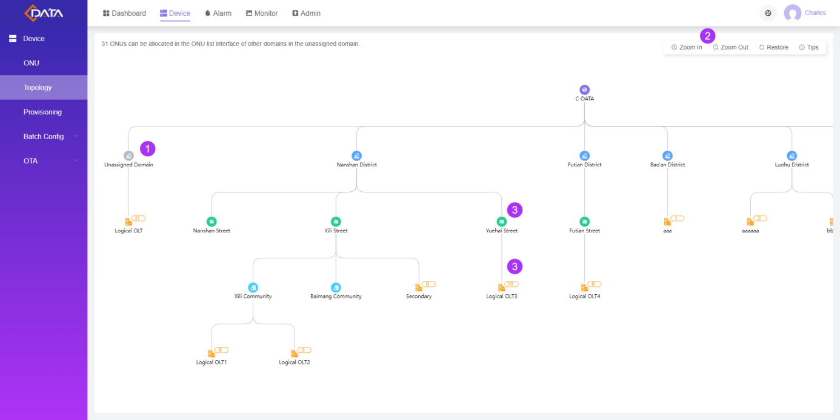

Main Window Introduction:

1. Unassigned Domain: By default, there are only unassigned domains. Please create a new enterprise complete domain classification in the [Admin - Domain] menu;

2. Zoom in/out: Scroll the mouse to zoom in/out topology map;

3. Domain Right-Click Operation: Right-click the mouse on the domain to add logical OLT;

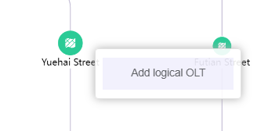

4. Logical OLT Right-Click Operation: Right-click the mouse on the logical OLT icon to maintain the ONU list, i.e., assign the domain location.

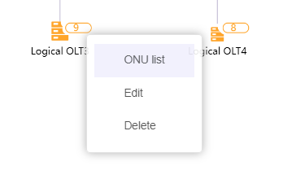

**2.7 Provisioning**

Click [Device - Provisioning] menu to enter the provisioning tasks interface as shown below.

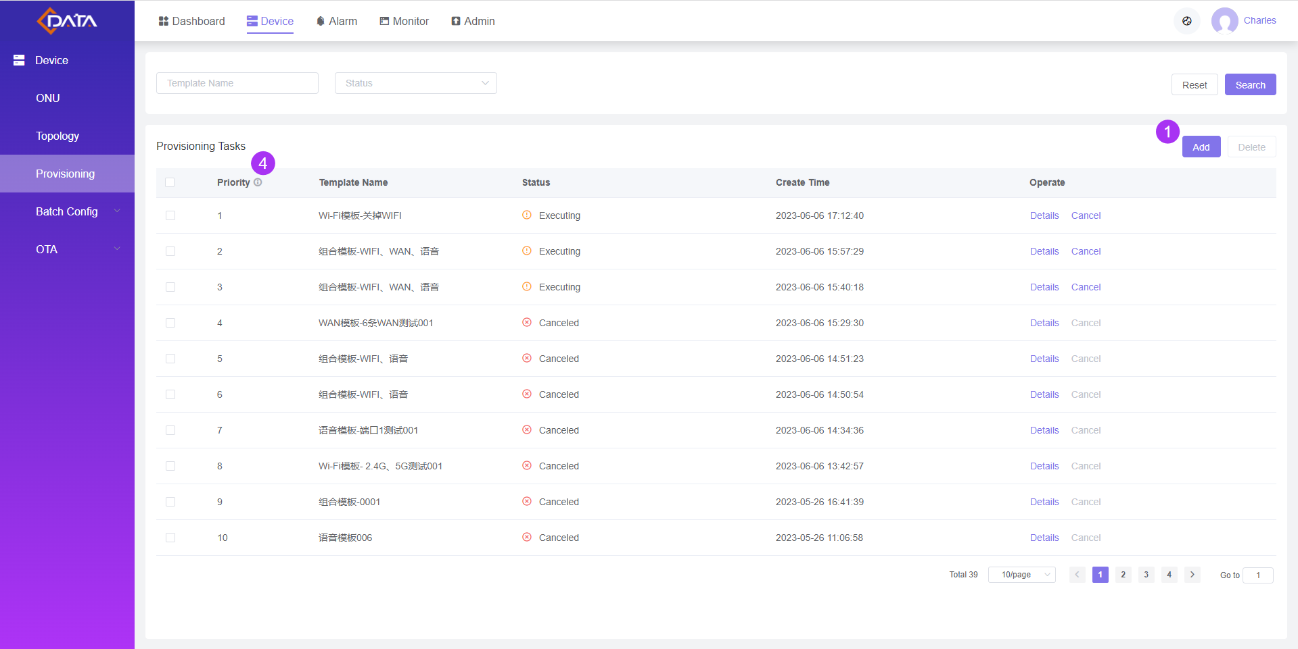

Main Window Introduction:

1. Add: Click to pop up a dialog box to add a new provisioning task, select a config template and set filter conditions for target devices. When a device matching the conditions is added for the first time, the config will be automatically issued.

2. Config Template: Manage in the [Device - Batch Config - Config Template] menu;

3. Config Target: Devices can be matched based on Vendor, Model or SN. When multiple fields are filled in, the intersection match will be taken. If none is specified, it implies that there are no restrictions, and any device reported for the first time will be automatically issued the config template;

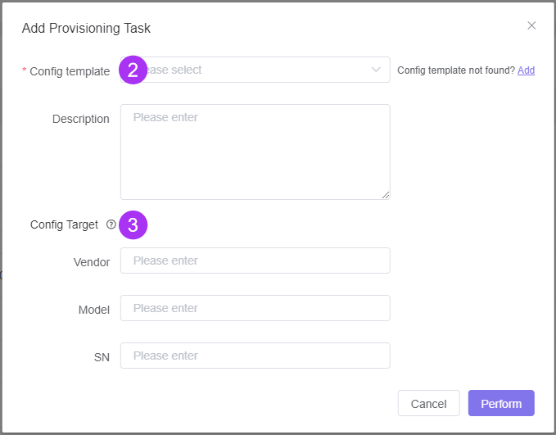

4. Priority: When multiple tasks exist for the same device, take the task with the highest priority to execute.

**2.8 Batch Config**

A configuration template needs to be created before batch configuration.

1. The configuration template interface is displayed as shown below, supporting the creation of WAN, Wi-Fi, VoIP and combination templates.

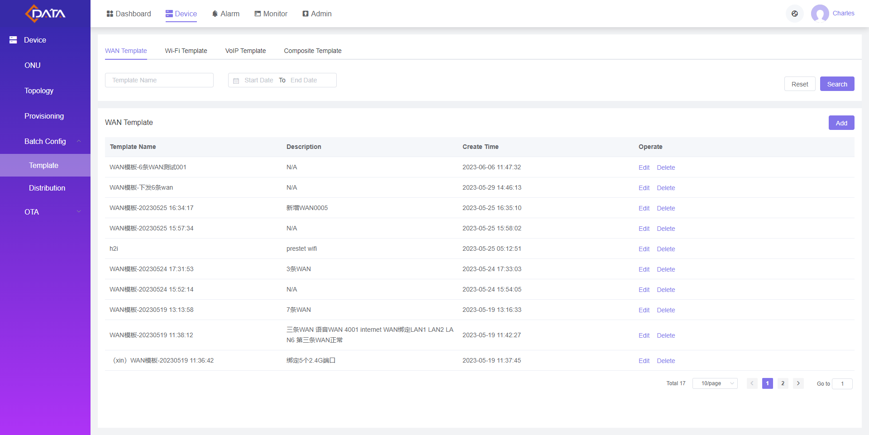

2. The distribution record interface is displayed as shown below. Click "Add" to create a new batch configuration.

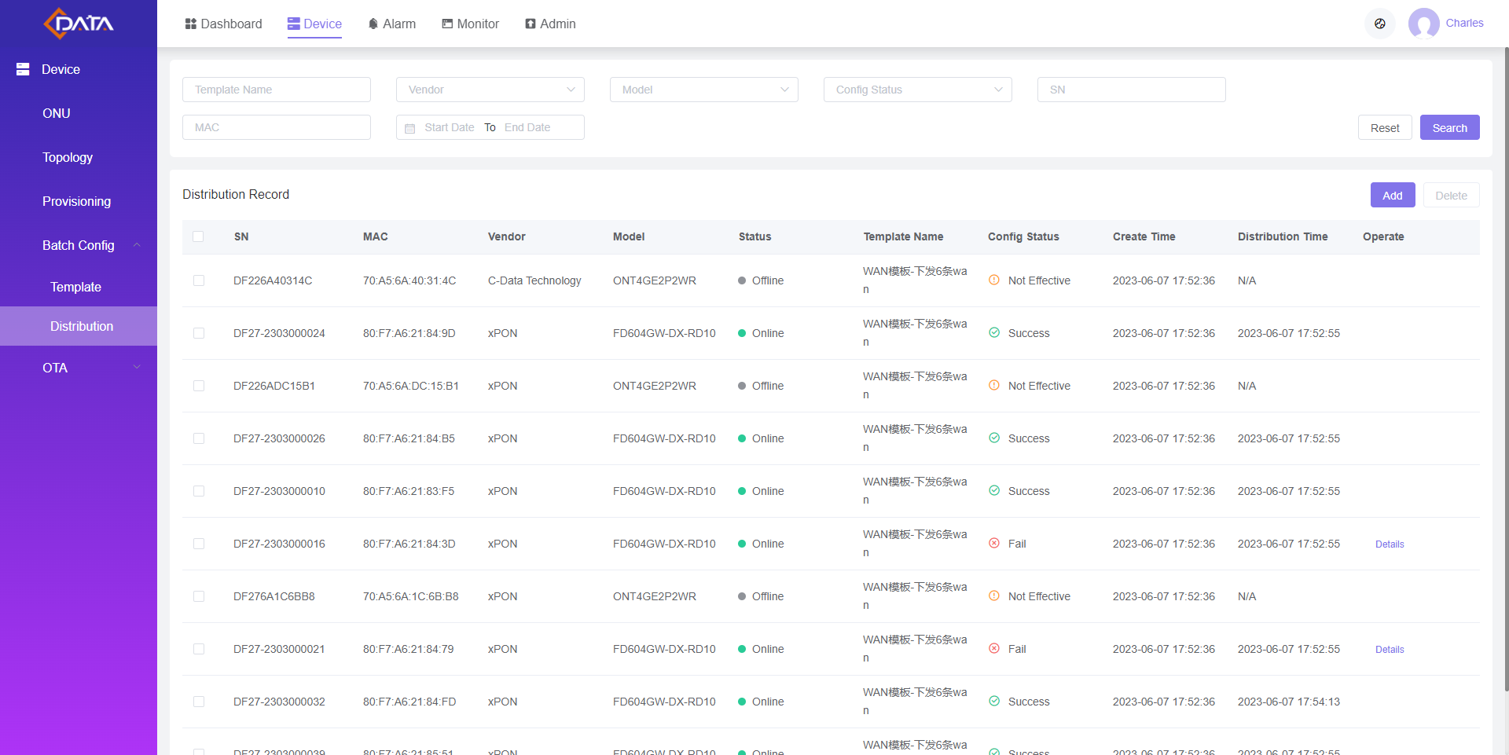

**2.9 OTA Upgrade**

OTA upgrade mainly includes the following two steps:

1. In the Firmware interface, upload the firmware info and verify it;

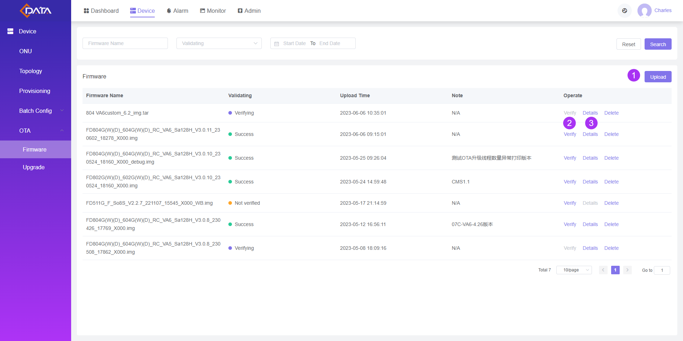

2. In the Upgrade interface, create and publish upgrade tasks and then check the upgrade progress and results.

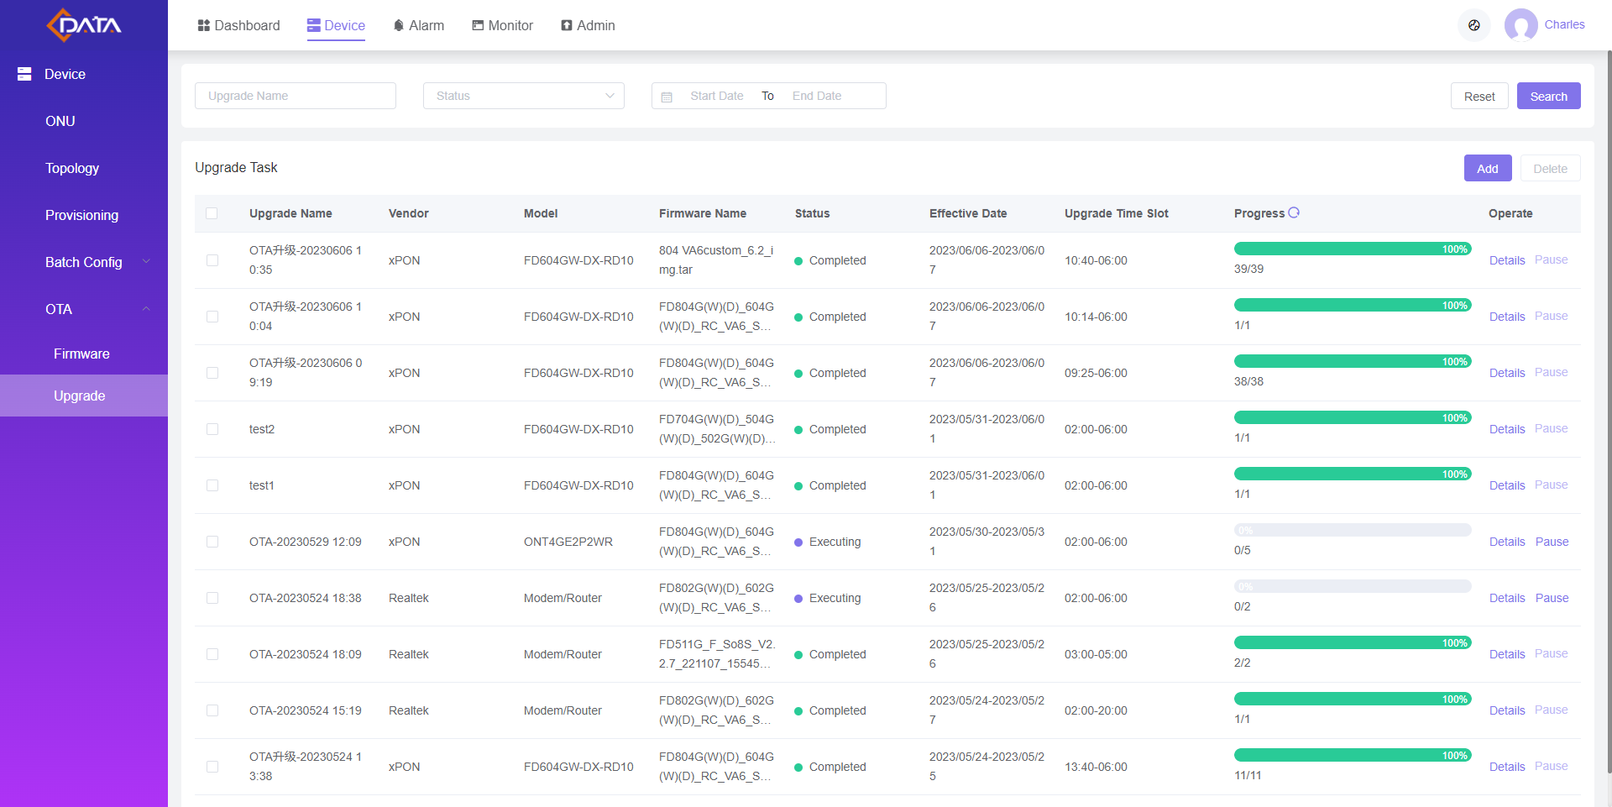

**3. Alarm**

**3.1 Real-Time Alarm**

Click [Alarm - Real-Time Alarm] menu to enter the ONU list interface as shown below.

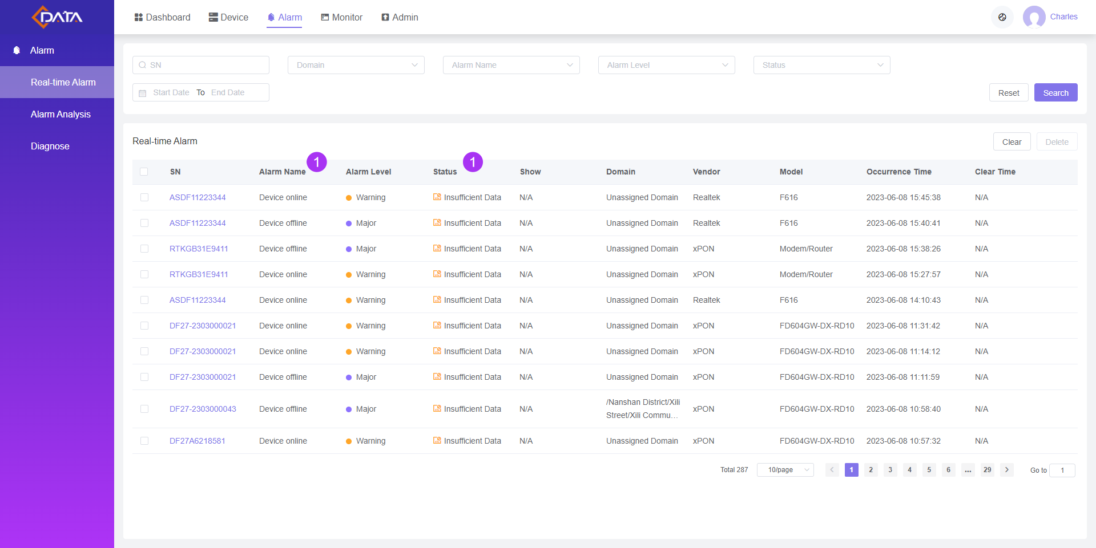

1. Alarm Name: The currently supported alarms are as follows, more types will be supported in subsequent versions.

* Device online/offline
* ONU loop detection
* ONU LAN port online/offline
* ONU receive/transmit optical power exceeds threshold
* ONU operating temperature/current/voltage exceeds threshold
* CPU/memory exceeds threshold

2. Status: When the device recovers from abnormal to normal, the status will be automatically switched.

**3.2 Alarm Analysis**

Click [Alarm - Alarm Analysis] menu, the interface will be displayed as shown below.

The system will intelligently analyze and provides real-time alarm warnings such as power outages, aging of optical devices, unstable power supply, etc.

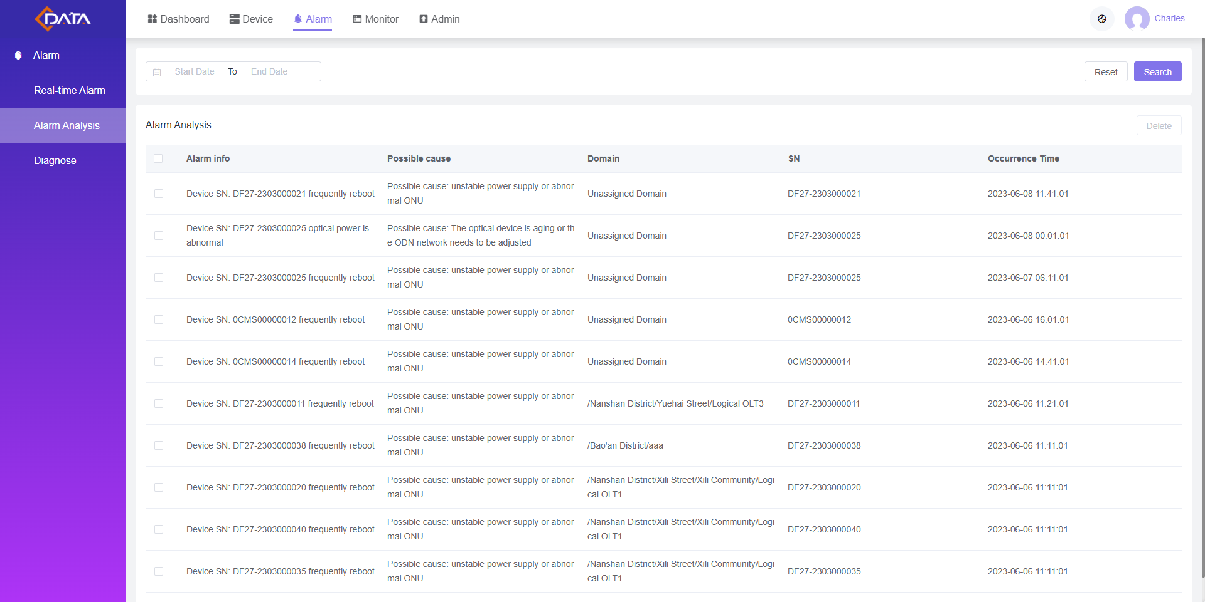

**3.3 Diagnose**

Click [Alarm - Diagnose] menu to quickly locate and fix device faults through a process-driven and automated diagnostic approach.

1. **User Reporting Fault**

Enter the device SN or MAC to display basic information and directly perform Ping and Tracert diagnosis.

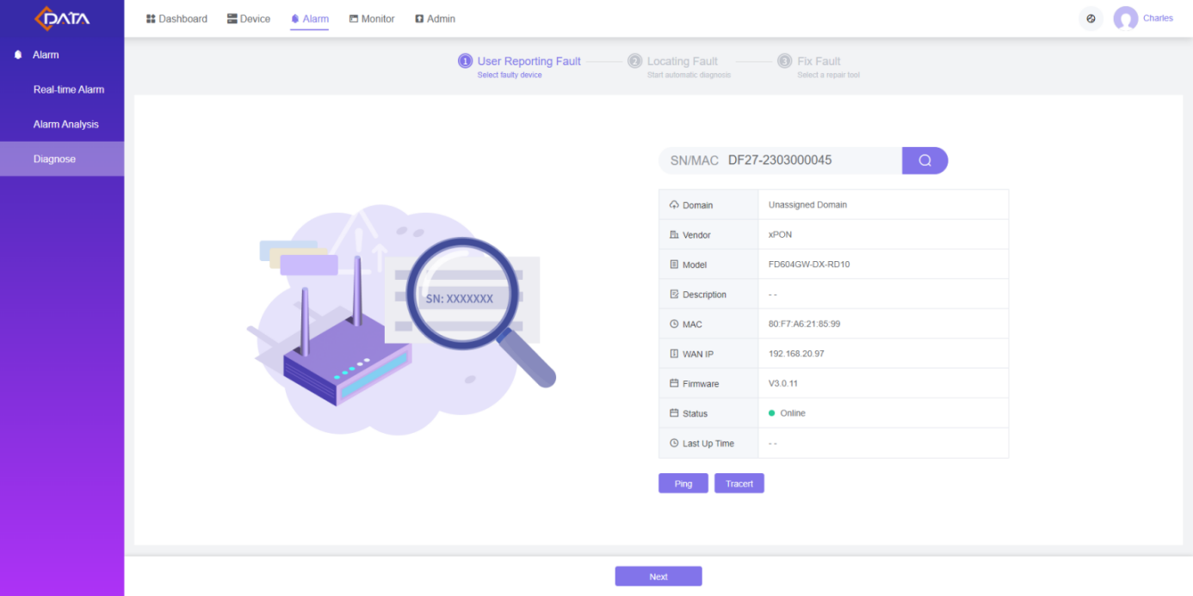

1. **Locating Fault**

Automatically conduct checks line information, business information, Ping, LAN/Wi Fi connection, DHCP, voice service and CATV, etc. Display the results and provide solution suggestions.

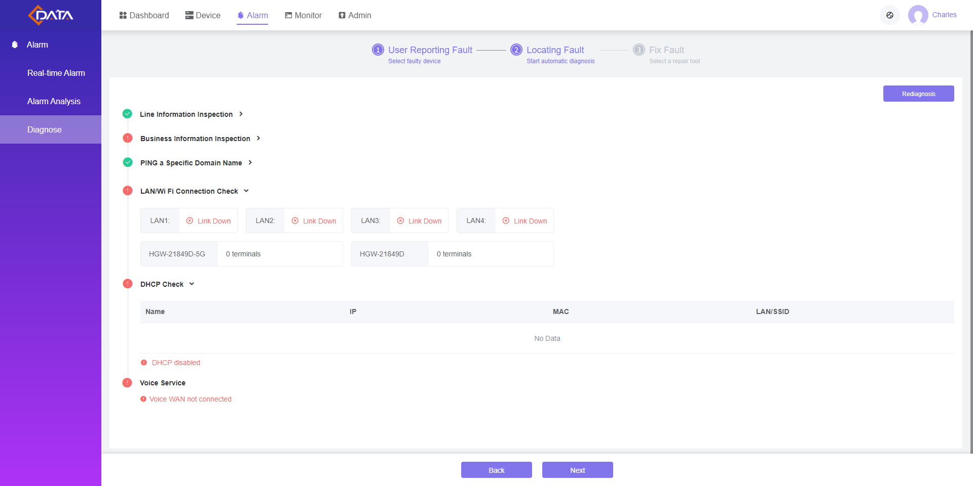

1. **Fix Fault**

Provide diversified fault repair tools based on the check results. After the repair is completed, the diagnosis can be performed again to confirm if the problem has been solved.

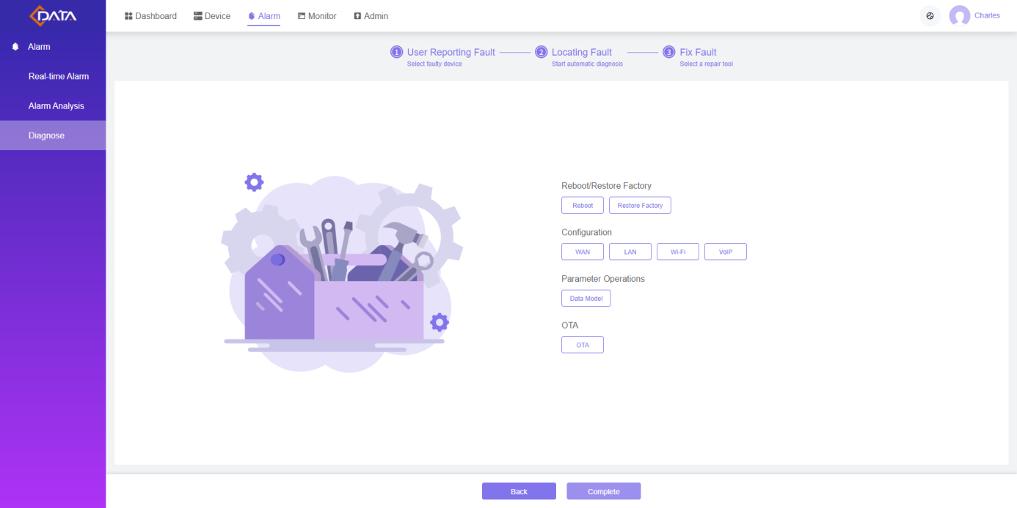

**4. Monitor**

By comparing the key indicators of multiple devices, monitor the operation status of the devices, this helps in identifying any abnormal indicators in time, to further analyze the issues.

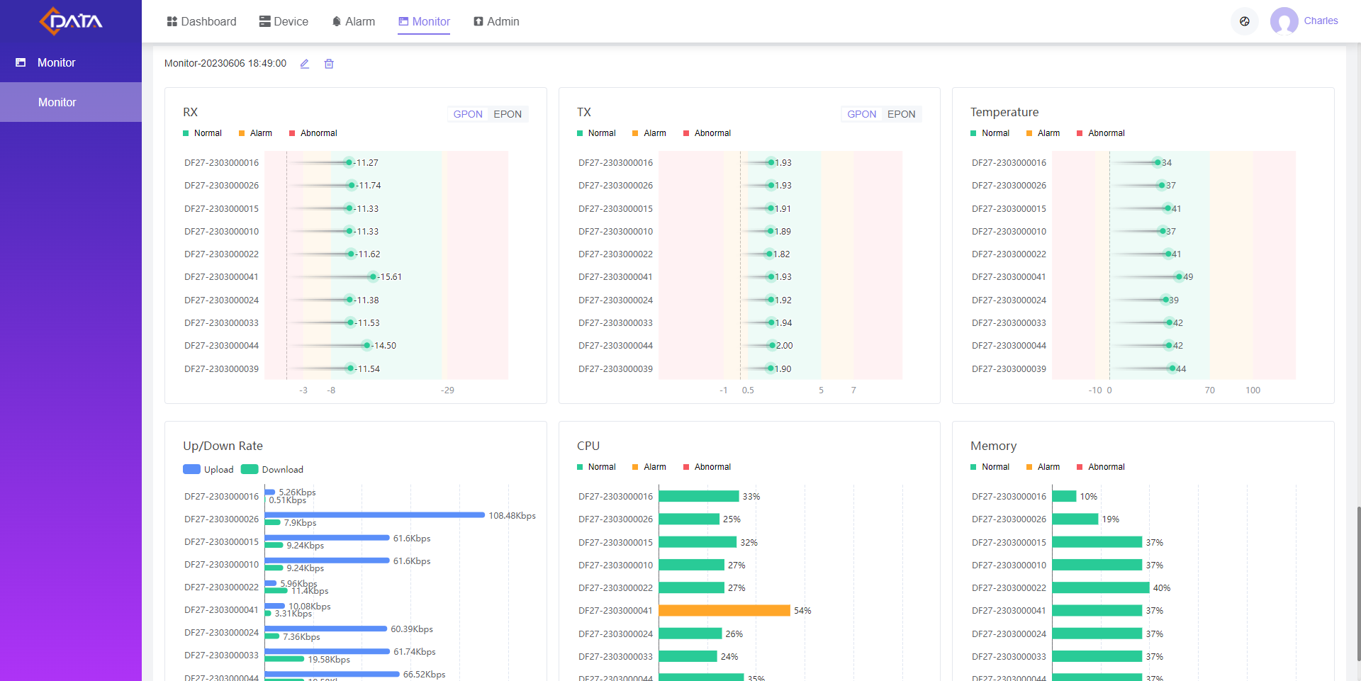

**5. Admin**

**5.1 Enterprise**

Click [Admin - Enterprise] menu to enter the enterprise information interface as shown below.

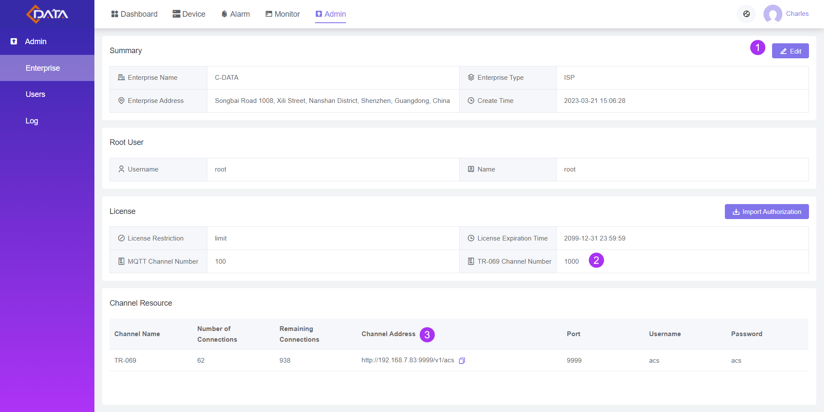

Main Window Introduction:

1. Edit: Customize various details including server address, enterprise name, Logo, etc.;

2. TR-069 Channel Number: The system provides 1000 devices added by default, and if additional resources are needed, please contact C-Data sales staff;

3. Channel Address: Used for adding ONU;

4. MQTT Channel Number: the system provides 10 channels by default, and if additional resources are needed, please contact C-Data sales staff.

**5.2 Users**

Click the [Admin - Users] menu to enter the user permissions interface as shown below.

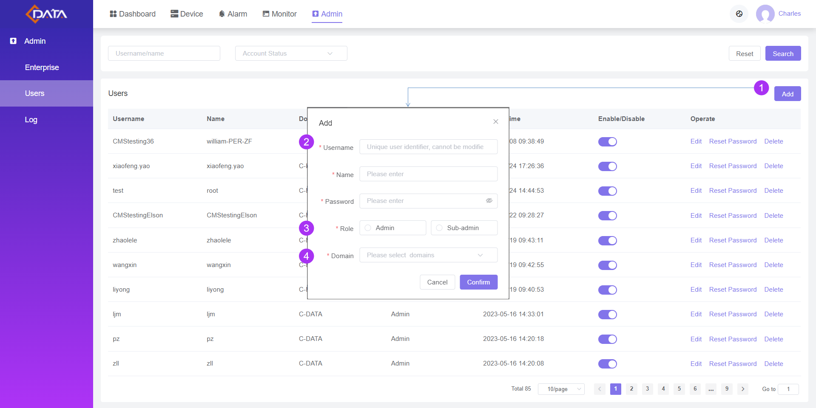

Main Window Introduction:

1. Add new;

2. Username: Used for logging into the system and cannot be modified after creation;

3. Role: The current system provides 3 roles of main administrator, sub-administrator and normal user. The main administrator is unique, while there can be multiple sub-administrators. The sub-administrators have the same permissions as the main administrator;

4. Domain: Select the domain scope managed by the current user. Users can only manage devices within their domain permissions; for sub-administrators, the domain scope is set to all domains by default.

**5.3 Domain**

Click [Admin - Domain] menu to enter the domain management interface as shown below.

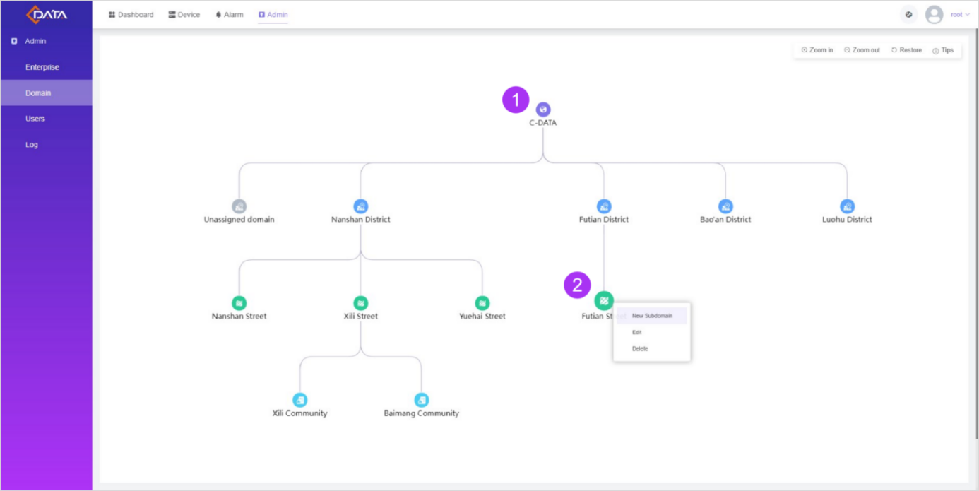

Main Window Introduction:

1. Root Domain: Only the root domain is displayed by default;

2. Domain Operation: Right-click on the domain icon to create a new subdomain.

**5.4 Log**

Click [Admin - Log] menu to enter the log information interface as shown below, including operation logs and login logs.

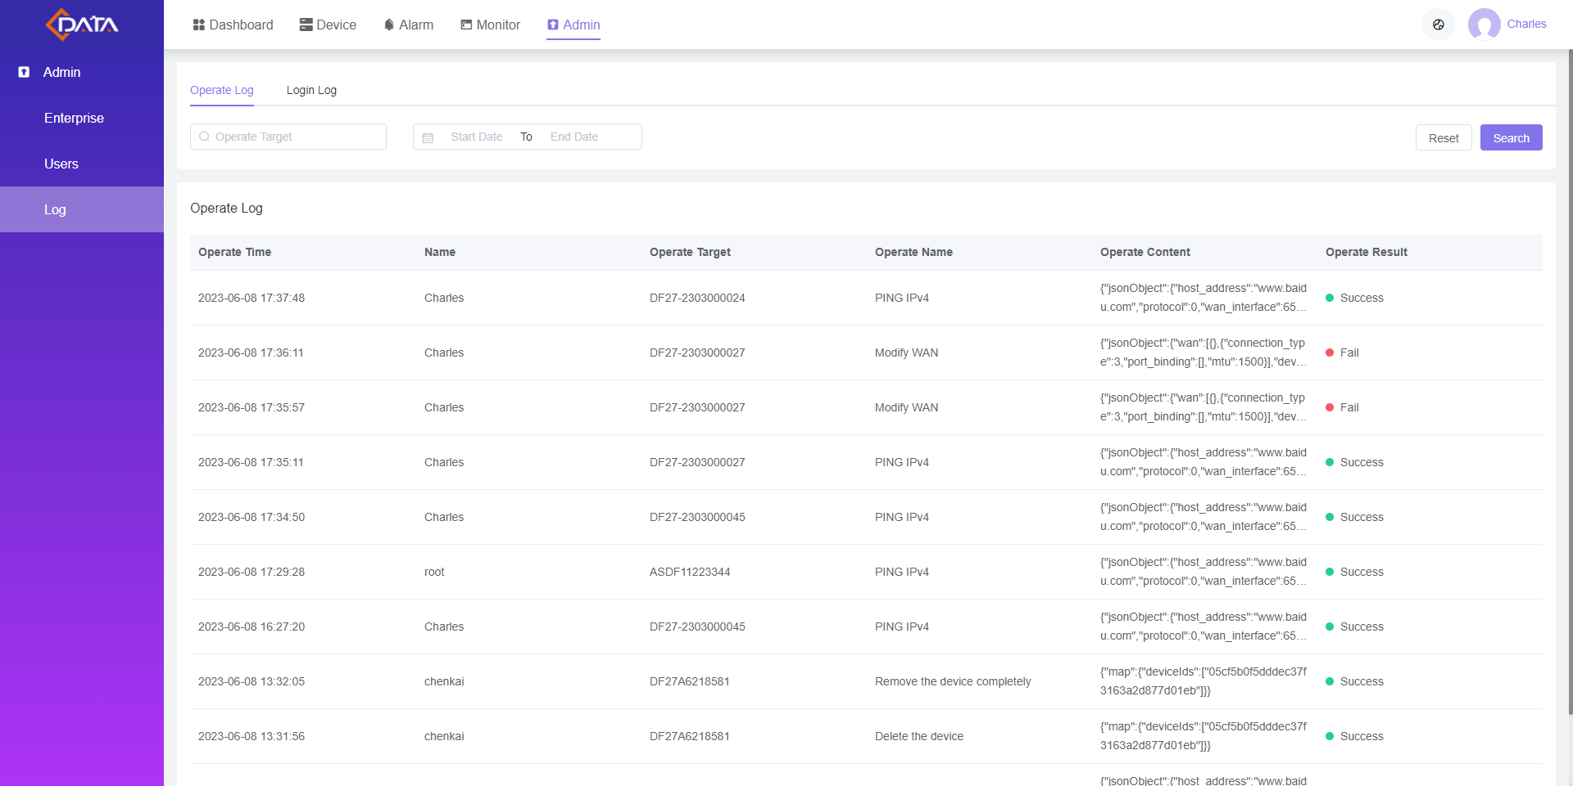

**Part IV Q&A**

* **CMS installation failed?**

1. Please check if the installation path exists in non-English characters.

2. Close the running CMS service and reinstall it.

* **Data loss after installing a new version of CMS?**

1. The installation path must be the same as the previous version.

2. When uninstalling the old version of CMS, select the option to keep user data.

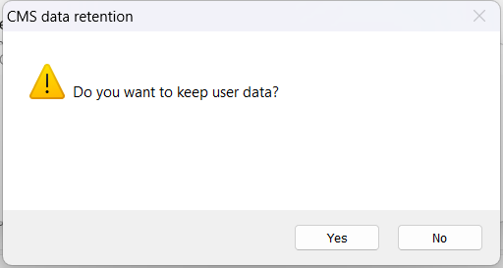

* **CMS service failed to start?**

1. Please check if the server port is occupied. If so, click the corresponding service tab and change the port number.

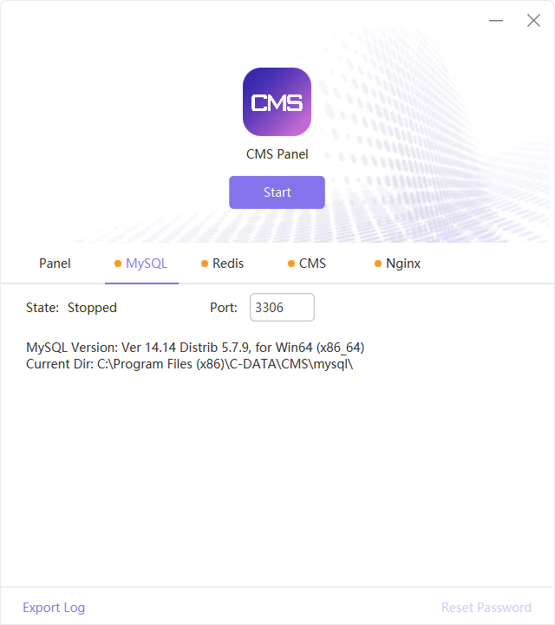

2. Export the log information and provide it to C-Data technical support for feedback.

* **What if the main administrator forgets the password?**

Click the "Reset Password" in the lower-right corner of the CMS Panel to reset the password.

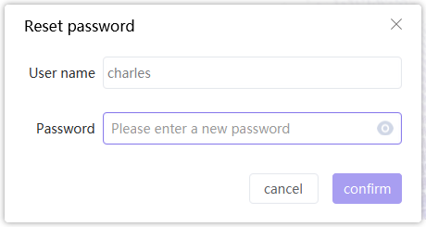

* **Unable to add ONU devices？**

1. Check whether the ONU Web report parameter is correct.

2. Currently, the default TR069 channel number is 100. Please make sure that the device number has not reached the upper limit. If you need to increase the number, please contact C-Data sales staff.

* **WAN/LAN configuration options do not exist or fail to configure?**

Currently, the system only supports the new version firmware 07C, and compatibility with other models is in progress.

* **Why are there two records with different SNs for the same device?**

For GPON SN, the old firmware takes the serial SN, while the new firmware (Version number: XXX and above) is changed to take the PON SN. This results in the old device being recognized as a new one with two records existing after upgrade. The serial SN record can be deleted thoroughly in ONU list.

* **Why can't I submit feedback?**

The network permission in CMS Panel needs to be opened to submit feedback.